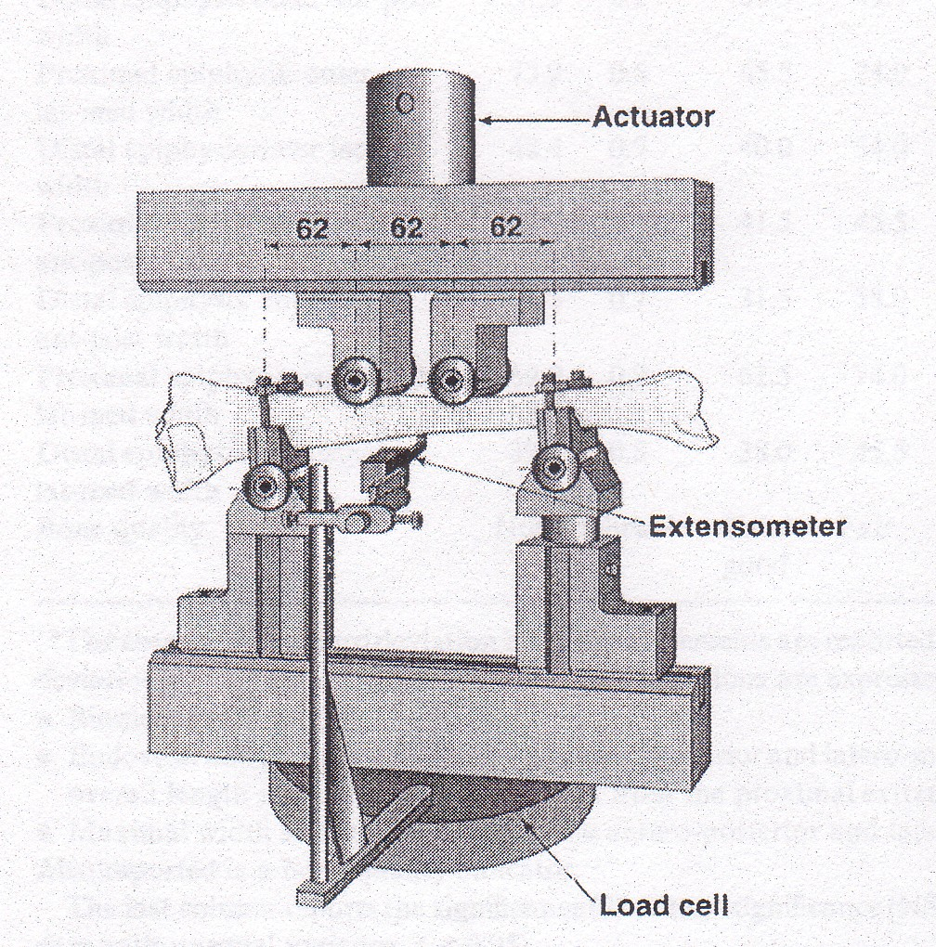
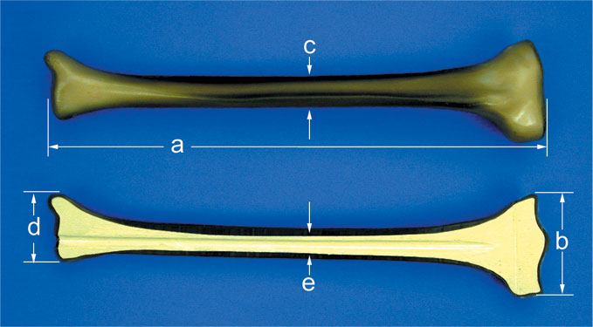

Technical Objectives
- Discuss the variety of material property choices that nature has made in various human body components.
- Compare and contrast nature as a designer to human engineers as designers.
- Explain the difference between strength and stiffness of a material.
- Define the ultimate tensile strength and modulus of elasticity of a material.
- Determine the modulus of elasticity of a bone using a bone bending apparatus.
- Determine the ultimate tensile strength of a bone using a bone breaking apparatus.

Differences Between Nature as a Designer and Man as a Designer
On planet Earth, nature has had to overcome many of the same challenges that human engineers have tried to overcome in the past 1000 years. However, in many cases human engineers have solved the same problems in very different ways than nature.

Examples of nature’s solutions vs. human solutions

Why haven’t human engineers done a better job of trying to emulate the success of nature?

BACKGROUND

Material Properties and Engineering Design
As an engineer, you will be called upon to make choices of which materials to use for each component in and engineering system. These choices will be based on the operating requirements (forces, temperatures, etc.) as well as cost, aesthetics, etc. Similarly, an examination of all human body parts shows that nature has made a variety of material property choices in her design of the human body.
In Physics I, you have so far assumed that all objects act as rigid bodies. In other words, the objects that you have studied have moved around, but they themselves did not deform. In real life, all engineering structures and components deform under applied loads and temperatures. Moreover, under certain conditions these components can break. The extent to which they engineering components deform (and whether or not they will break) is governed by their material properties.
The purpose of this laboratory module is to determine the performance of one particular body component (the tibia bone) under the applied forces for which it was designed by nature.
List of Material Properties
Some of the material properties that impact the performance of each component in the human body are:
Density, ρ [kg/m³] [lbm/ft³]
"Stiffness" - Modulus of Elasticity, E [Pa] [psi]
Shear Modulus, G [Pa] [psi]
Ultimate Tensile Strength, σ_{u} [Pa] [psi]
Brittleness Temperature [º C] [º F]
Specific heat, C_{p} [J/kg-K] [BTU/lbm-F]
Thermal conductivity, k [W/m-K] [BTU/hr-ft-F]
Electrical resistivity, ρ [ Ohm-cm]

Homogeneous, Isotropic Materials vs. Composite Materials
For the first 1000 or so years of engineering, human beings have spent much of their effort developing engineering materials that are homogeneous and isotropic.
Homogeneous –

Isotropic –

Composite materials are made up of a mixture of more than one type of material. These inhomogeneous materials have unique properties that often take advantages of the benefits of each of the individual constituents.
Examples of homogeneous, isotropic materials Examples of composite materials

Although nature uses composite materials extensively, human beings have been developing their own composite materials for only the last 50 years or so!

Review: Stress and Strain
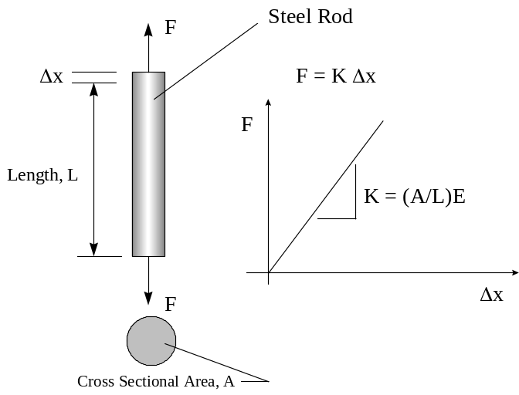
Recall from last week’s laboratory that most engineering materials behave just like springs. The amount that a rod stretches is directly proportional to the applied load. So, if we were to plot Force vs. deflection for a rod of a given length and cross sectional area, find that force varies linearly with Δx.

For a rod with length, L, and cross sectional area, A, the equation for Force vs. Deflection is:

(1) 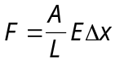

So, the slope of the force vs. deflection line depends on the geometry (length and cross sectional area) as well as a material property, E, which we will discuss shortly. Unfortunately, while the above diagram contains information useful to the analysis of a specific rod under consideration, it cannot be used directly to predict the deformation of rods with different dimensions.

However, we can modify the above equation by collecting some terms a little bit differently:

(2) 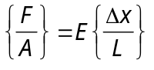

The above equation allows us to introduce several definitions.

Stress (defn.) Stress, σ, is defined as the force per unit area on a material. It has dimensions of F/L², and units of PSI or Pa.

(3) 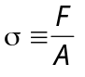

Strain (defn.) Strain, ε, is defined as the deformation per unit length. It is dimensionless.

(4) 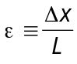

So, we can rewrite the equation (2) in a form that is, now, independent of the dimensions of the system:

(5) 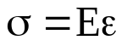

where σ is the applied stress, ε the strain and E the modulus of elasticity. This equation is also called Hooke’s Law.

Stress-Strain Curve

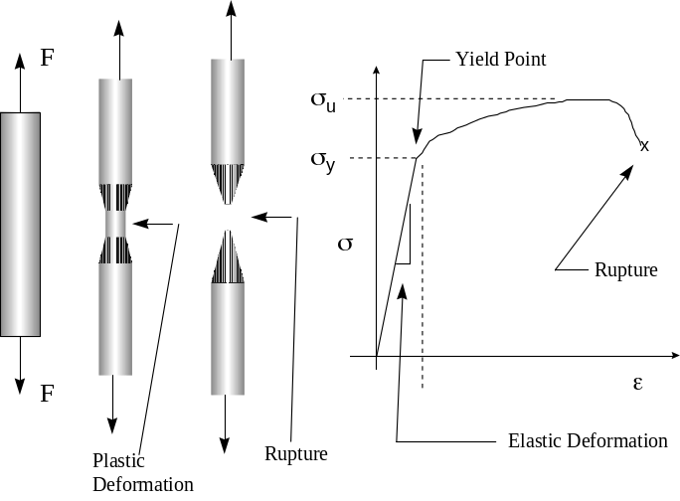
We can now make a plot σ vs. ε which is independent of the size and shape of an object and is only a function of the material itself. A typical stress-strain curve is shown below.

Strength vs. Stiffness of a Material

Strength
The strength of a material is the maximum stress that a material can handle before it begins to permanently deform or break.

Stiffness
The stiffness of a material is the “spring constant” of a material. It is a measure of how much the material will deform for a given stress. The material property that measures stiffness is called modulus of elasticity.

Definitions from the Stress Strain Curve
Modulus of Elasticity (Also called Young’s Modulus): is the “spring constant” for a material undergoing elastic deformation. Also referred to as “stiffness”. It also has units of PSI or Pa.

Yield Strength, σ_{y} (defn). The amount of stress a material can undergo before it begins to permanently deform. [PSI, Pa].

Ultimate Tensile Strength, σ_{u} (defn). The maximum amount of stress that a material can handle. [PSI, Pa]

What is a “high stiffness”, vs. a “low stiffness” for an engineering material?

PVC: 330,000 PSI
Polypropylene: 160,000 PSI
Oak: 1,600,000 PSI Typical bone: 2,600,000 psi
Aluminum 3003: 10,000,000 PSI
Stainless Steel 316: 28,000,000 PSI

What is a “high strength” vs. a “low strength” for an engineering material?

PVC: 6,000 PSI
Spruce: 9,000 PSI
Oak: 17,000 PSI Typical bone: 18,000 psi
Aluminum (pure): 16,000 PSI
Aluminum (2024 alloy): 68,000 PSI
Titanium alloy: 130,000 PSI

What body parts has nature designed with high modulus of elasticity? What body parts has nature designed with low modulus of elasticity?

What body parts has nature designed with a high strength? What body parts has nature designed with a low strength?

Brittle vs. Ductile Materials
Ductile Materials (metals, plastics, skin):
For a ductile material stress varies linearly with strain only under low strain:

Brittle Materials (glass, ceramics, teeth):
Brittle materials, like glass or ceramics do not yield prior to rupture.
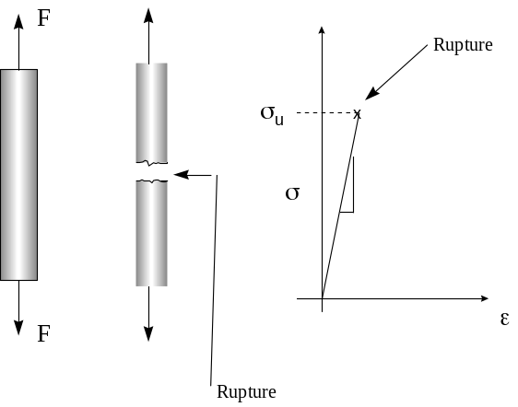

Nature’s Material Choices in the Human Body
Consider again some human body parts. Can you name some good material choices vs. some bad material choices? Why did nature not do such a good job in some cases?

THE BONE LAB
The Human Skeleton
The skeleton system is the body’s frame, its foundation. Like a building, the body needs a way to support the forces exerted by every day activity. Bones are the body’s load bearing supports. Helped by muscles the bones carry the weight of the body and protect vital organs.
The purpose of this laboratory is to determine the effectiveness of bones as the human body’s load bearing structural members. In the laboratory, the modulus of elasticity of a bone will be determined, using a cantilever beam bending apparatus. And the ultimate tensile strength of an animal bone will be determined using a beam breaking apparatus.
Bones
Bones in the body have at least six functions:
- structural support
- locomotion
- protection of various organs
- storage of chemicals
- nourishments, and
- sound transmission (in the middle ear).
This laboratory will focus on the support function of a bone, which is essentially a function of two mechanical properties: strength and stiffness.
Many people believe that a bone is an inactive part of the body, but in actuality a bone is living tissue with nerves and its own blood supply. Cells make up about 2% of the volume of bone and if these cells die due to poor blood supply the bone can die and lose its strength. Throughout a person’s life, specialized bone cells perform a continuous process of destroying old bone and building new bone. Osteoclasts destroy the bone, and osteoblasts build it. While the body is young osteoclasts work slower than osteoblasts, but after the body is 35 to 40 years old, the activity of the osteoclasts is greater than that of the osteoblasts causing a decrease in bone mass. This is what causes serious bone problems, such as osteoporosis, as we get older.

Bones are Composite Materials

Bones consist of two different materials, collagen and bone mineral. Collagen is a very soft and flexible material while the bone mineral is very hard and brittle. Bone needs to be both firm and flexible to properly perform its function in the body. If bone were too firm it would be brittle and break very easily. If it were too flexible it would not be able to support the body. This is the reasoning for the two types of materials. Collagen is produced by the osteoblasts and mineral is then formed on the collagen to produce bone. The bone mineral itself is made up of calcium hydroxyapatite, which is similar to some common rocks found in nature. In fact almost half of bone is made up of calcium, which, because of its heavy nucleus, makes it so easy to view bones using x-ray technology.

Composite materials are materials that are made up of two or more distinctive parts that are used for their specific properties. Composite materials are very useful because they can utilize the beneficial properties of all the materials that make them up. Bone is a composite material, if you were to saw bones in half you would see that they are composed of a combination of two different types of bone: solid bone (compact) and spongy bone made up of thin threadlike trabeculae-trabecular bone. There are two advantages of trabecular bone over compact bone. When a bone is subjected to compressive forces trabecular bone gives the strength necessary with less material than compact bone. Also, trabecular bone is more flexible so trabecular bones in the ends of long bones can absorb more energy when large forces are involved such as in walking, running, and jumping.

Bone Bending
Human skeletal bones, such as the tibia and femur in your leg have been designed by nature to resist bending under transverse loading. Still, these bones actually do bend and, as many of you may know from experience, bones can also break under excessive force. We can analyze the stress and deflection in a bone the same way we analyze a transversely loaded beam in civil
When a bending force is applied to a beam there is relatively no stress in the center but the top and bottom are put into compression and tension respectively (see figure). That is, the bottom is being pulled apart while the top is being force together.
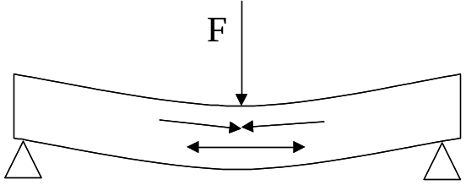

Since the stress is highest at the top and bottom of the bone, (and zero in the middle), nature has designed bones to be hollow such all the bone material is on outer radius.

Analysis of a Bone in Bending

Recall from last week that, for a rod in tension with an applied axial load, F, the deflection (δ) is calculated as follows:

(6) 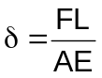

Note that deformation of an engineering component is always a function of three things:

- Applied load (F)
- Geometry (L / A)
- Material properties (E)

For a beam (or bone) in bending, the deformation is also a function of load, geometry and material properties according to the following equation:

(7) 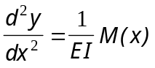

In equation (7), the deformation is actually the second derivative of y with respect to x, the applied load is the bending moment M(x), the material properties are the Young’s modulus, and the geometrical parameter is the moment of inertia, I.

Moment of Inertia

In axial loading, the cross section area, A, is the geometrical parameter that resists stretching. A fatter rod will stretch less than a skinny rod under the same applied force, F.
In bending, the geometrical parameter that resists bending is not the cross sectional area. Rather, it is the moment of inertia, I. To resist bending, civil engineers use I-beams. Similary, to resist bending, nature has designed bones as tubes, with the majority of the material as far as possible from the centerline.
Moment of inertia is easily calculated for simple geometrical cross sections as follows:

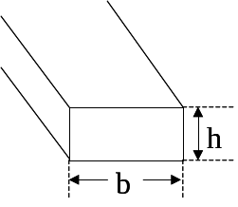
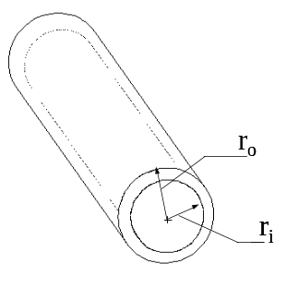
For a rectangular cross section: For a hollow, circular section:
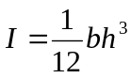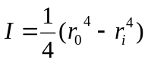

Exercise 1.

Calculate the Moment of Inertia for the center cross section of the human femur bone.

Exercise 2.
Derive the equation of the elastic curve for a bone clamped at one end.

Consider the following skeletal bone, clamped at one end. (A beam that is clamped at one end is called a cantilever beam. )

Draw actual clamped bone here

Believe it or not, it is possible to solve equation (7) to derive an exact equation for the deformation of the bone, y(x) as a function of location along the bone, x. The solution, y(x) is called the equation of the elastic curve.

To illustrate the solution of equation (7), which is called a differential equation, we can re-draw the cantilever bone as follows:

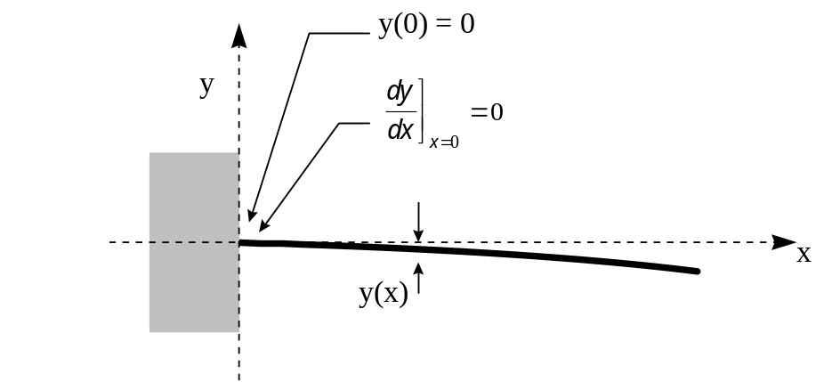

To solve the differential equation (7), we need to specify two conditions on the solution y(x).

In the case of the clamped end, not only is the deflection specified, but the slope is also fixed as well. Thus, the conditions at the clamped end are:
y(0) = 0
y’(0) = 0

Solution of the Equation (7) for the Cantilever Bone
In this section, you will solve the differential equation (7):

(7a) 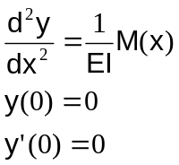

Solution of equation (7) will allow you to determine the equation of the elastic curve y(x) for the cantilever bone.

The first step is to draw the free body diagram of the clamped bone.
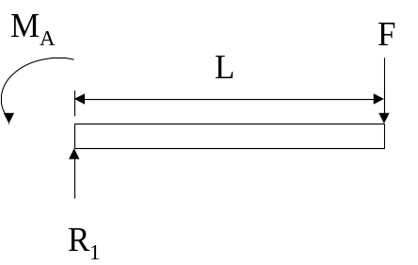

- Using the principles of statics, solve for the reaction force, R₁ and the reaction moment M_{A}. Sum the forces in the y-direction.

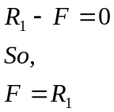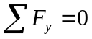
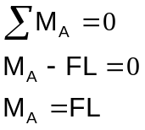

- The next step is to derive an equation for the internal bending moment M(x) for the beam. Draw the free body diagram for a slice of the beam at any point where 0<x<L.
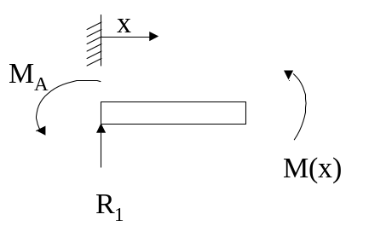
- Next, sum the moments at the broken section of the beam.

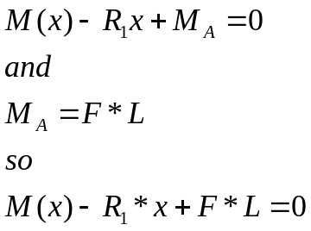


But from the force balance it is known that F=R₁, so the internal moment can be simplified as follows:

(8) 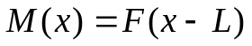

- Finally, we can formulate the differential equation that can be solved to determine the deflection of the beam.

(9) 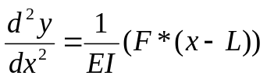

This equation is called a differential equation. This equation needs to be solved in order to find the function, y(x) that describes the deflection of the beam. In words, the equation reads, “Find the function, y(x), whose second derivative with respect to x is equal to 1/EI multiplied by F(x-L).”

- Solve the differential equation (9) by integrating (treating E, I, F, and L as constants).
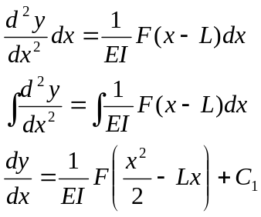

The above equation describes the slope of the bone at each location x.

Integrating again will give us the function y(x).

(10) 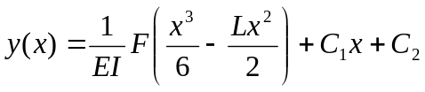

- At this point, the general form of the function, y(x) has been determined. However, the exact solution is still not known. The constants C₁ and C₂ need to be determined. The constants are determined using the boundary conditions.

For a simply supported beam the boundary conditions are:
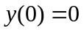
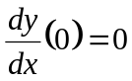

Plugging in the first boundary condition we get:

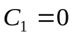

Plugging the second boundary condition into dy/dx we get:

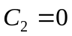

The equation now becomes:

(11) 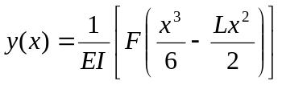

Equation (11) is an exact equation that describes the deflection of the beam y(x) for the entire length of the beam (0 < x < L).

For the end loaded cantilever bone, the maximum deflection occurs at the end, x = L. Thus, equation (11) can be solved for the maximum deflection by substituting x = L:

(12) 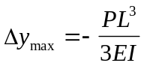

Equation 12 can be used to measure the modulus of elasticity of bone. Having calculated the modulus elasticity of the bone, by applying a load, P, to the end of a cantilever bone, and measuring the deflection, Δy, it is possible to solve for E.

Experiment: Bone Stiffness
Determine the modulus of elasticity, E, of the human femur bone.

Experimental Procedure

- Measure and record the inner diameter of the bone.
- Measure and record the outer diameter in the direction that the force is being applied. (Assume the bone is a circle.)
- Measure the length from the edge of the inner circle screw hole to the end of the bone.
- Secure the bone to the clamp using the two screws. Push the bone down so that it is secure.
- Place the dial gauge at the end of the bone.
- Record the initial position of the gauge as the zero position.
- Zero the load reading by pushing the black button on the right upper corner of the machine.
- Bring down the crosshead using the lower adjusters until the load cell reading no longer changes.
- Record the distance moved and the force reading.
- Now using the top adjusters apply more force in intervals of 0.02 inches and record the force reading.
- Repeat the previous step until eight measurements have been recorded.
- After the experiment is performed, release the force from the bone, and remove the bone from the clamp.
- Calculate the Moment of Inertia, I.
- Make a plot of applied Force, F, vs. Deflection Δy.
- According to equation (12), the slope of the curve is equal to 3EI/L³. Solve for E in psi.

Follow-up Questions
- Does the modulus of elasticity make sense? Compare to steel, plastic and wood.
- Compare the Modulus of Elasticity found from the Sneaker Material laboratory to the Modulus of Elasticity obtained from this experiment. Which is larger and give reasons for the differences?
- The artificial bones that were tested are made up of a glass fiber reinforced epoxy composite material. Write a short description on another composite material and its uses.

Experiment: Bone Strength
So far, we have calculated the stiffness of a bone by measuring the deflection of a clamped bone vs. the applied load. It is also possible to calculate the ultimate tensile strength of a bone by applying a transverse load until the bone breaks.
Recall that for a rod undergoing an axial load, the normal stress is simply the force divided by the cross sectional area. In fact the stress is nearly constant across the cross section.

In bending, however, the normal stress varies throughout the cross section. Consider the following bone:

This configuration is called a simply-supported beam since it is not clamped at either end.
For this configuration, it can be shown that the maximum normal stress as a function of applied load can be calculated as follows from:
(13) 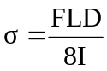

where F is the applied load [lb], L is the length of the bone [in], D is the diameter of the bone [in] and I is the moment of inertia [in⁴]. By performing an experiment in which a bone is loaded with a force F until it breaks, we can determine the ultimate tensile strength, using the equation above.

References

Beer, Ferdinand. Mechanics of Materials. W.C.B. McGraw Hill, New York: 1992

Bu Park, Joon. Biomaterials Science and Engineering. Plenum Press, New York: 1984

Cameron, John R. Physics of the Body, Second Edition. Medical Physics Publishing. Madison, WI: 1999.

