Introduction to HYSYS Simulation
Piping Calculations
Robert P. Hesketh
Chemical Engineering, Rowan University (Revised 4/27/2001)

In this exercise you will simulate a piping network based on homework that you have previously completed. You will be using a chemical process simulation package from Hyprotech Inc of AEA Technologies. This program is used by industry to design and simulate process plants such as oil and gas refineries, chemical and pharmaceuticals production facilities. A typical sampling of well-known companies using this software are given below:
- DuPont, Eastman Kodak, Monsanto, Hoechst Celanese, Rohm & Haas
- Shell, Amoco, Exxon Chemical, Olin, Conoco, Phillips
- Foster Wheeler, Arthur D. Little, Ballard, Koch
- Hoffman LaRoche, International Flavors and Fragrances,
This software is written in C++ which is a language that you have learned. The cost of this software is approximately $45,000 for the dynamic version and $20,000 for the steady-state version. This price is for only one user! For more information on Hyprotech go to www.hyprotech.com

The overall process for this simulation is to
- Select a thermodynamics package that describes the physical and chemical properties of the chosen chemicals
- Select the pipe segments and unit operations
- Define all required inputs and output streams. Specify required values of temperature, pressure, flowrate and chemical concentration.

Piping Equipment
Piping Equipment is described in the HYSYS manual in adobe pdf files located at from \\engnet1\apps\Hysys_Doc\Menu.pdf in the Plant Menu, under Steady State Modeling in Chapter 4: Piping Equipment. This manual states that:
The PIPE SEGMENT is used to simulate a wide variety of piping situations ranging from single/multiphase plant piping with rigorous heat transfer estimation, to large capacity looped pipeline problems. It offers two pressure drop correlations: one developed by Gregory, Aziz and Mandhane, and the other by Beggs and Brill. Four levels of complexity in heat transfer estimation allow you to find a solution as rigorous as required while allowing for quick generalized solutions to well-known problems.

The PIPE SEGMENT offers three calculation modes: Pressure Drop, Flow, and Length; the appropriate mode will automatically be selected depending on the information supplied. In order to solve the pipe, you must supply enough information to completely define both the material balance and energy balance.

Start your computer:
Rowan University has a license to run HYSYS PLANT version 2.2, which is both a steady state and dynamic simulation program.

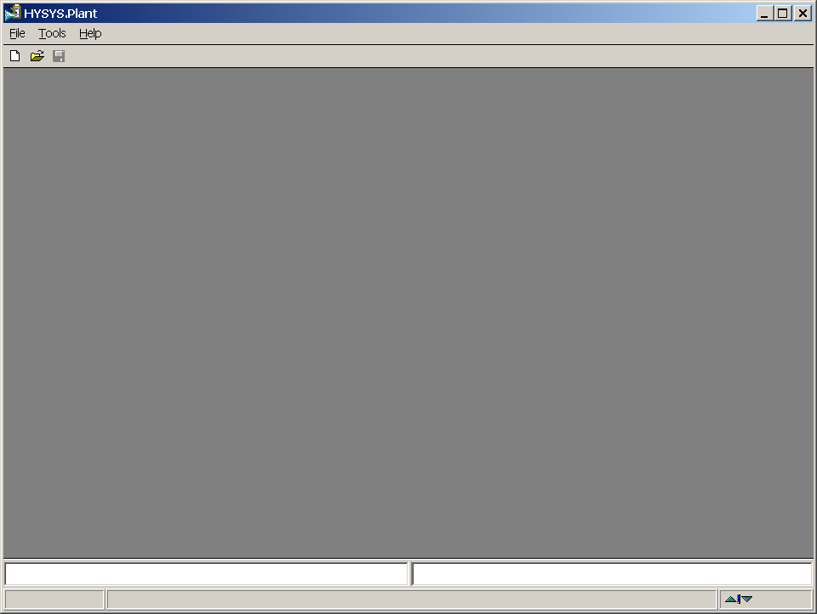
For convenience Hyprotech suggests that you copy the HYSYS directories to your personal drive on galaxy. These are located in \\galaxy\public1\chemical engineering\HYSYS (To do this you may need to map a drive (Start, Windows Explorer, Tools, Map Network Drive…,) In these directories you will save your configuration files and cases.

In HYSYS there is a limited online Help package, which can be obtained using the Help command from the menu bar or by pressing the F1 key. There is an extensive collection of manuals that can be accessed from \\engnet1\apps\Hysys_Doc\Menu.pdf. Remember that we are running HYSYS PLANT.

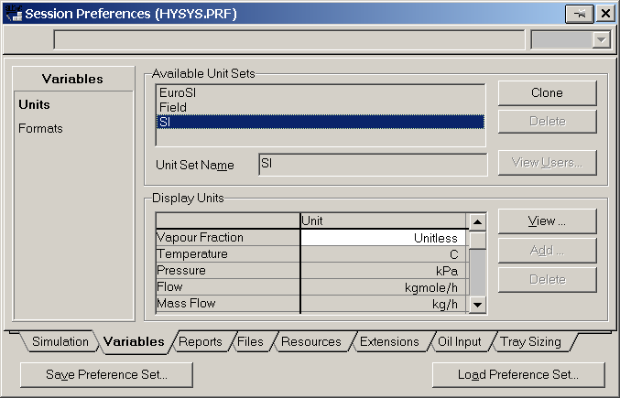
- Start HYSYS PLANT
Third Floor Lab (windows NT) Start => Engineering Network apps => Engineering Apps => HYSYS Plant
First floor labs (windows 2000) Press Start => Engineering Apps =>HYSYS Plant
This package will take about a minute to start up and when complete you will see the screen given above.

In this introduction to the use of piping equipment in HYSYS we will solve several examples from quizzes, homework and exams. In most of these examples we will use water as the fluid.
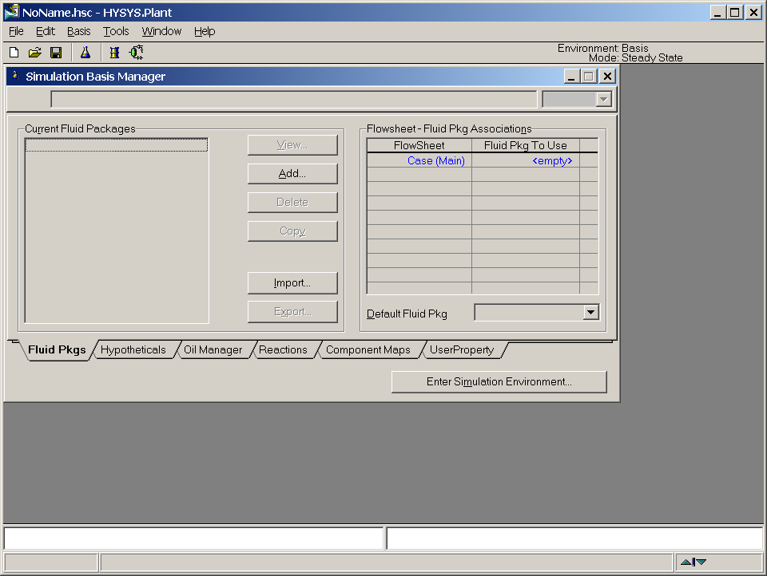
2a
To start a new case click on the white page icon or use the commands File New Case. See previous page.
- Change your units from American engineering to SI: (if necessary)
  - Go to the command Tools, preferences
  - Choose the Units tab
  - Select SI
  - Press Save Preference Set to your galaxy drive
  - Press close.

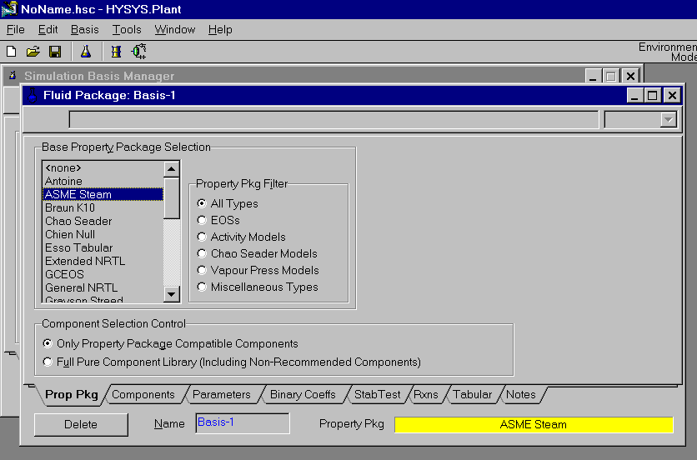
The result will be the following menu screen to choose a thermodynamic property package. You will learn more about these packages in your chemical engineering thermodynamics course. We will use the ASME Steam Tables as our property package. HYSYS includes two steam packages:
3b
3e
3c
• ASME Steam
• NBS Steam
Both of these property packages are restricted to a single component, namely H₂O. ASME Steam accesses the ASME 1967 steam tables,. The limitations of this steam package are the same as those of the original ASME steam tables, i.e., pressures less than 15,000 psia and temperatures greater than 32°F (0°C) and less than 1500°F. Selecting NBS_Steam utilizes the National Bureau of Standards (NBS) 1984 Steam Tables, which reportedly has better calculations near the Critical Point.

- Choose the Property package and chemical components
  - Choose the button Add…
  - Choose ASME Steam
  - Press the Components tab
  - Add water by selecting one of the water components - H₂O and pressing the Add Pure button. Yes this is a bit silly!
  - Press the x or close button for this screen
  - Press the Enter Simulation Environment… Button (see figure above)

You should now see the following screen titled PFD - Case (Main). In the green screen you will construct a process flow diagram (PFD) of a flash process. The pictures of equipment shown to the right of the green screen contains the equipment that you will add. In this exercise we will add equipment simulating a flash.

- Save the file on your galaxy drive. File, Save as, and change the path to your personal galaxy drive. I would suggest always saving your files with a unique descriptor (your name). The files are always printed with your filename showing on the page. To determine which letter designates your galaxy drive, open Windows Explorer and find the letter corresponding to your “galaxy” drive.
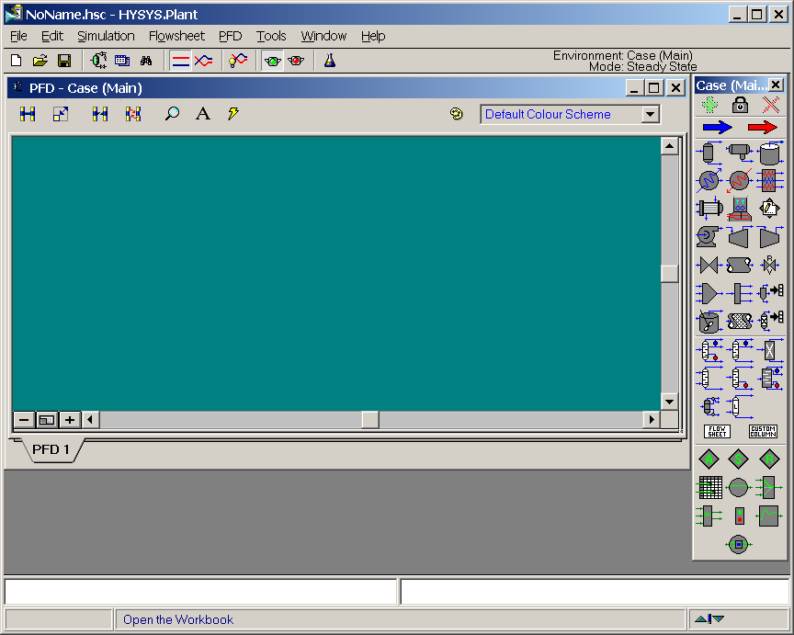
- Select a material stream by double clicking on the blue arrow and the menu labeled 1 will show on the pfd screen. Notice that a yellow warning sign appears telling you what is required: “Unknown Compositions.” The other warning colors are red: “requires a feed stream,” and green for “OK” for it has been solved.
Fit to Screen
Enlarge or (PgUp)
Reduce or (PgDn)
Zoom by Mouse
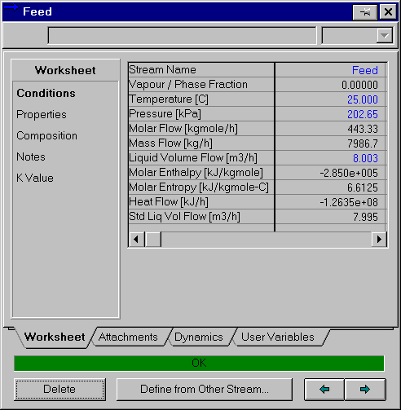
- Fill out this menu as follows:
  - Stream Name: Feed
- For the first example we will calculate the pressure drop of a horizontal pipeline based on Quiz 2 on 16 February 2001. Calculate the pressure loss in a horizontal 10 m plastic pipe containing water flowing at 4 m/s. The density of water is 1000 kg/m3 and the viscosity of water is 0.001 kg/(m s). The pipe is Schedule 40, 1” nominal diameter (1.049 in. or 0.0266 m ID).
  - Type in your value of pressure as 2 atm. Type in the number, a space and the letters atm. Hit return and notice that it converts the units to SI automatically!
  - Now this part is really silly! You have to tell HYSYS the composition of the stream even though you only have water in the pipe line! To specify mole fractions of water do either:
    - select the composition options on the left side and click on the Edit button or
    - double click on the cell next to Molar Flow [kgmol/h]:
  - Then type in the mole fraction as 1 for water.
  - The volumetric flowrate, based on 4 m/s and a diameter of 0.0266 m is 0.002223 m³/s. (Remember that you can enter the value in m³/s and it will convert it to the standard units.
  - Assume a temperature of 25°C.
  - Check to see that all of your values are as show in the feed stream window shown above. Make sure the only items that you have specified are in blue!

You will notice after you enter the value of Vapour/Phase Fraction, the remaining values of this stream are calculated by HYSYS. The values in blue are the ones that you have entered and the values in black have been calculated by HYSYS. To enter in a new number you must first delete a stream value and type in a new number. Since most printers are use only black ink the values that you have specified are designated with an asterisk in the upper right hand corner.
- Now add the pipe segment show in the adjacent graphic.
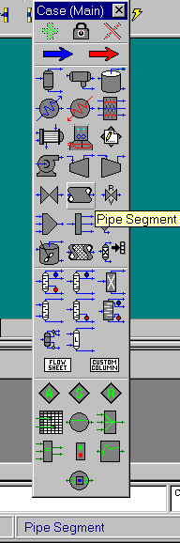
- Select the feed stream from the drop down list.
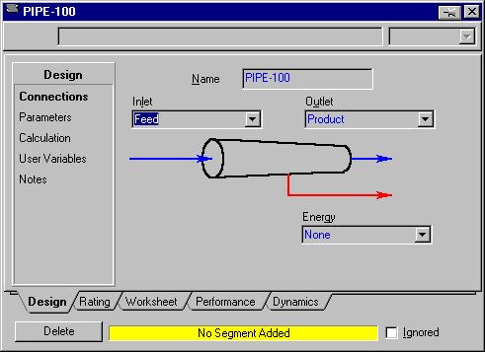
- Fill out the remaining streams as shown in the figure below.
- Next go to the Parameters page and specify a heat loss of 0.
- Now go to the Rating tab and press Add Segment. Add a pipe length of 10 m. Specify the Pipe Material as smooth by choosing this value from the drop down list.
- Press View Segment and select Schedule 40. Then click on the nominal diameter entry and select the 1 inch diameter. To choose one of the options – click on 25.4 mm and press the specify button.
- After this action the pipe line segment will calculate a pressure drop and the status bar on the PIPE-100 segment will turn green. Go back to the Parameters page and look at the pressure drop. You should have a value of 51.37 kPa.
- Save your case in your personal drive by executing the commands File, Save choose your drive letter and give a unique name to the case.
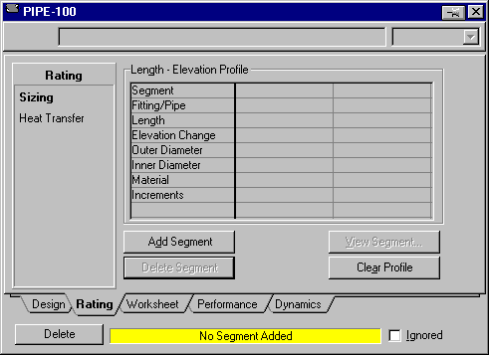
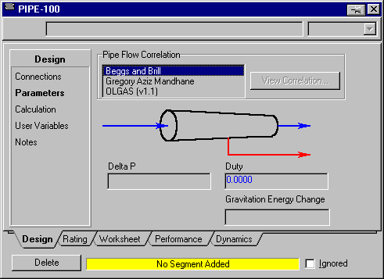

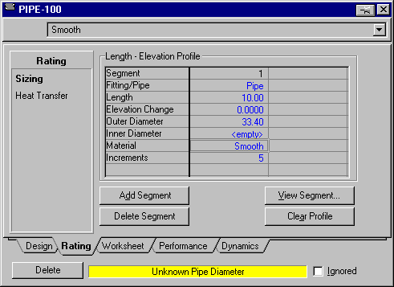
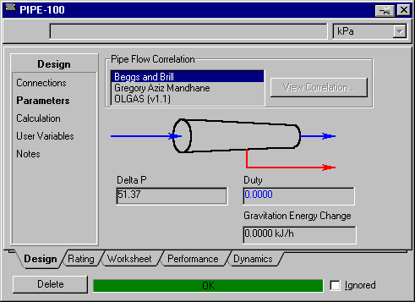
Roughness Factors used by HYSYS:
Pipe Material Type Absolute Roughness, m
Drawn Tube | 0.0000015
Mild Steel | 0.0000457
Asphalted Iron | 0.0001220
Galvanized Iron | 0.0001520
Cast Iron | 0.0002590
Smooth Concrete | 0.0003050
Rough Concrete | 0.0030500
Smooth Steel | 0.0009140
Rough Steel | 0.0091400
Smooth Wood Stave | 0.0001830
Rough Wood Stave | 0.0009140

Pipe Flow Quiz 3
Now let’s solve pipe flow quiz 3. Calculate the velocity in a horizontal 10 m plastic pipe containing water with the pressure drop in the pipe equal to 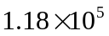 Pa. The pipe is Schedule 40, 1” nominal diameter (1.049 in. or 0.0266 m ID). If you remember from this quiz this is a trial and error calculation, since the flowrate or velocity are not given.
- To solve this problem first delete the specification of flowrate in the feed stream.
- Next go to the the parameters page of the pipe segment and specify the pressure of 118 kPa. Now wait for the green bar to appear!
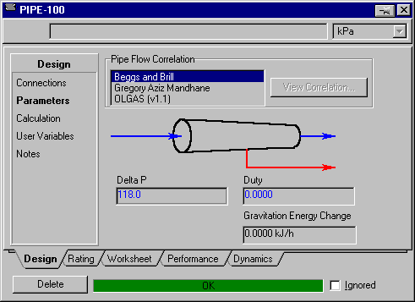
- To see the velocity go to the performance tab and select View Profile
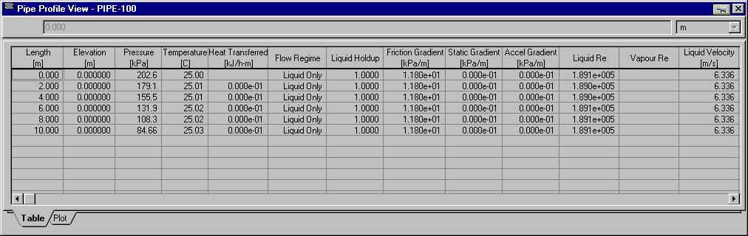
- To duplicate the figure below you will need to resize the window. Another option is to use the scroll bar to see the velocity. HYSYS gives the velocity as 6.336 m/s which is nearly identical to the value of 6.3 obtained from the trial and error solution on the quiz.
Cutlip and Shacham Problem 5.10: Calculation of the Flow Rate in a Pipeline
In this problem you are supposed to calculate the flowrate of water in the pipeline at 60°F. The pipeline is nominal 6 in. diameter schedule 40 commercial steel pipe with L = 5000 ft, P₁=150 psig, P₂ = 0 psig and z₁= 0 ft and
z₂ = 300 ft.
- For this problem we will change to units to Field Units. Go to Tools and choose Preferences
- Select the Variables tab and choose Field.
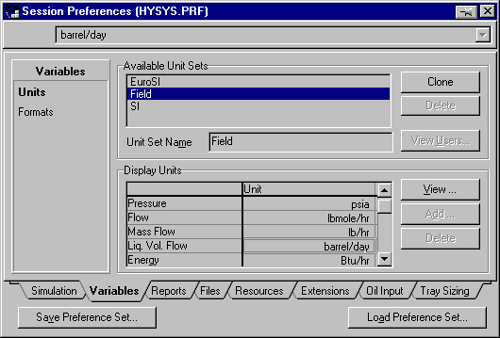
- Examine the units for flowrate and you will see that it is in Barrell’s per day! Let’s change that to GPM. Press the clone button.
- Give the Unit Set a new name: such as US GPM units
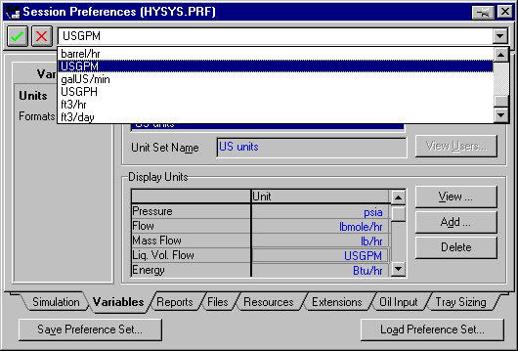
- Select the units barrel/day and choose US GPM from the drop down list.
- Save the preference Set in your drive on galaxy.
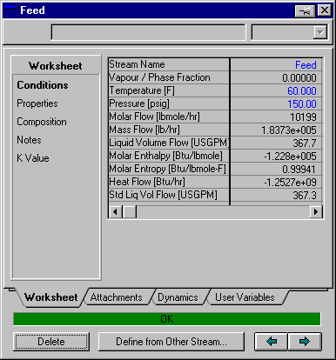
- Now make the following changes. Set the Feed stream temperature to 60°F and the pressure to 150 psig. Remember to select psig units otherwise HYSYS will assume absolute units. After you select these units it will immediately convert the pressure to absolute. To avoid this go back and change the default units of pressure from psia to psig!
- Delete the pressure drop reading in the Design tab – Parameters window of the pipe segment.
- Next change the pipe length to 5000 ft and the elevation to 300 ft. Change the Pipe to 6” nominal schedule 40 constructed from Mild Steel (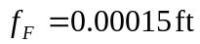).
- Now go to the Design tab and choose parameters. Type in 150 psi and wait for the program to converge!
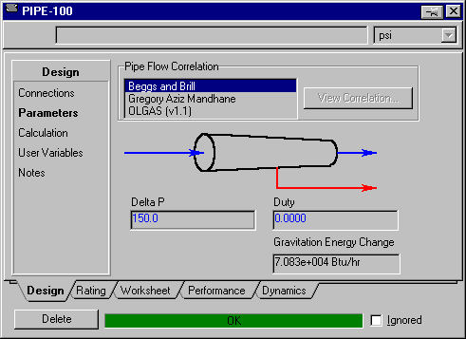
- The liquid flowrate is given in several places – see worksheet tab as well as the Feed stream. The flowrate given by HYSYS for the liquid volume flow is 367.7 GPM which is within 0.4% of the value given in the solutions provided by Hesketh.
- To complete the Cutlip and Shacham problem change the inlet pressure or Feed stream pressure to 200 psig.
- A useful set of tools for solving the Cutlip and Shacham problem are in the HYSYS DataBook. Go to Tools, Databook.
- Select Insert. And add the following variables: Feed, Actual Liquid flow and then press the Add button.
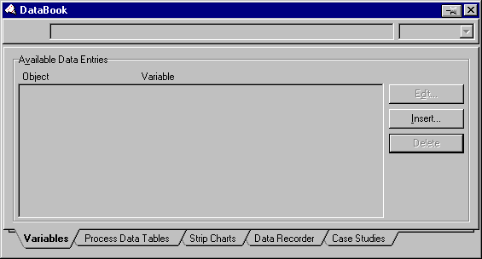
- Repeat for the pipe segment.
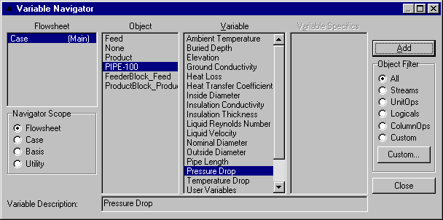
Press Close and then choose the Process Data Tables. Select Add All Variables and then view. From this new screen you can change the pressure drop value and have the calculate velocity displayed. Remember that it takes a while to converge the pipe segment. Look at the bottom left hand corner of the screen to determine what HYSYS is doing. See the next page for an example.
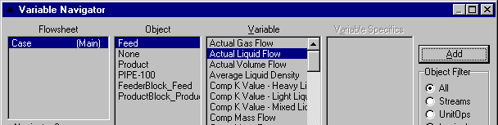
- See the manual for more details on the Databook.

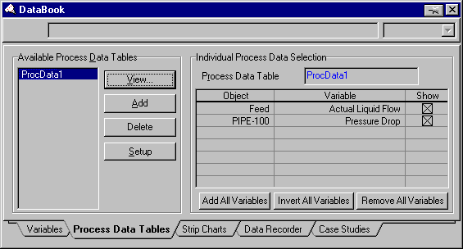

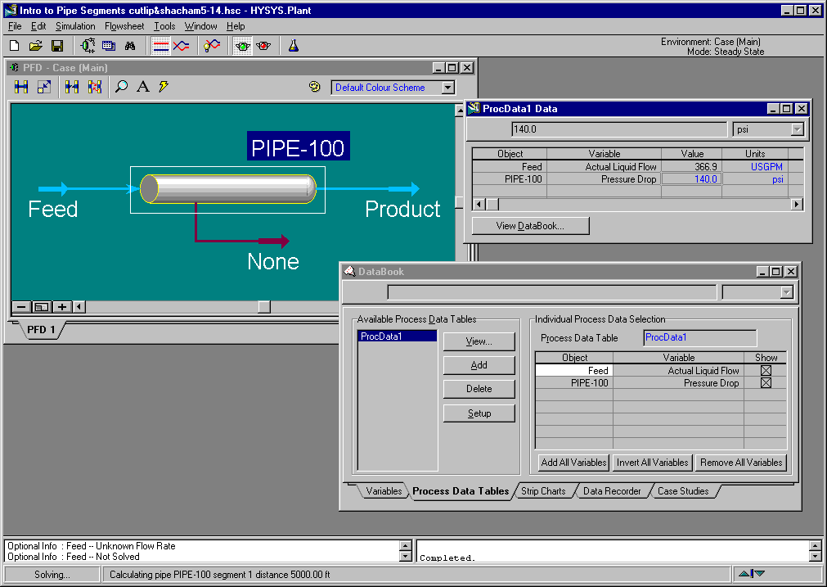

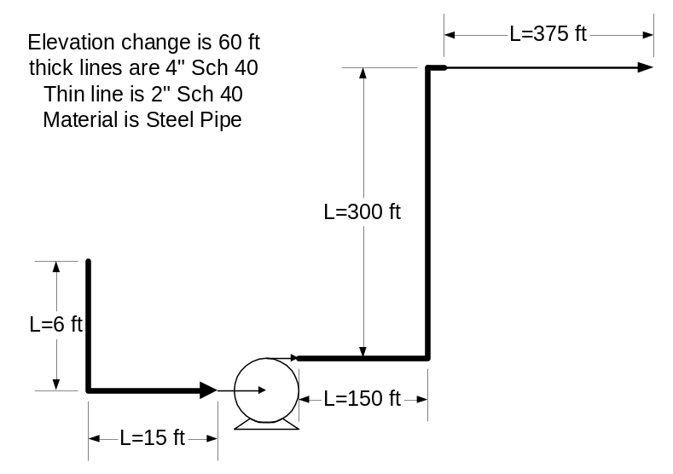
Cutlip and Shacham Problem 5.13 Pipe and Pump Network

In this problem we will modify the above case to include fittings and a pump. Water at 60°F and one atmosphere is being transferred with a 2 hp pump that is 75% efficient. All the piping is 4 inch schedule 40 steel pipe except for the last section, which is 2 inch schedule 40 steel pipe. There are 3 4 inch nominal diameter standard 90° elbows and one reducer to connect the 2 inch pipe. The change in elevation between the start and the end is 60 ft.

- In this problem modify the previous case by deleting the pressure drop.
- Then add the following all of the pipe segments in one pipe section as follows: 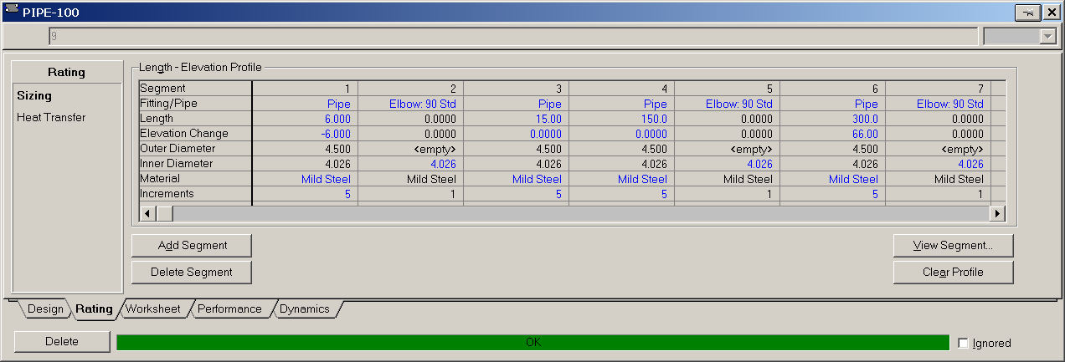
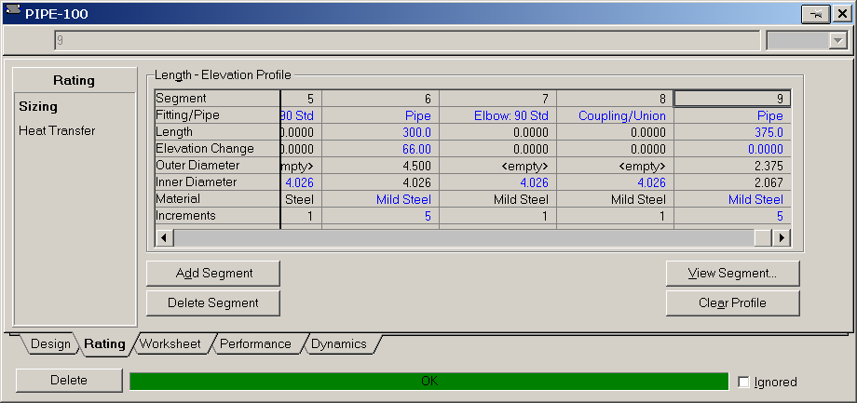
- Try a value of 65 GPM as the input and determine the pressure drop required.
- Now add a pump. Is the pressure drop 39.6 psi.
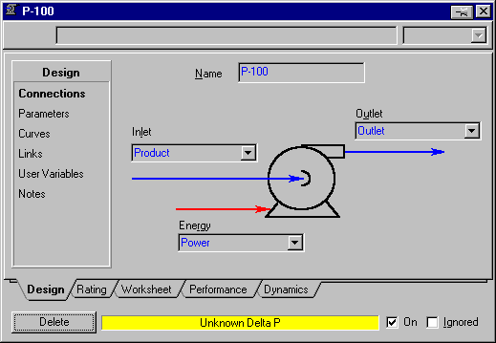
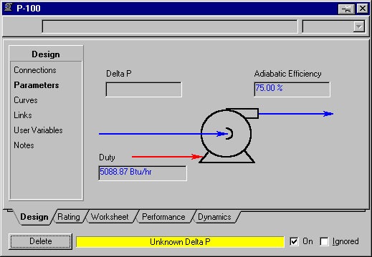
Printing out Documents:
            - Printout the pipe segments: Use the following format
            - To print the pipe segment double click on the pipe segment. Select the push pin and then go to the print button.
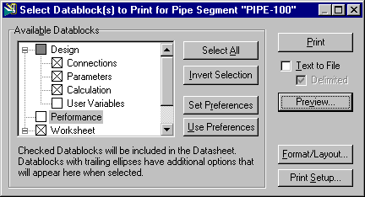

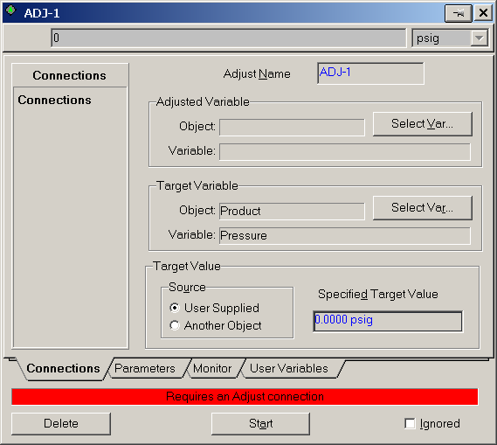
Bonus Problem: The REAL Cutlip & Shacham 5.13
From the above analysis you know that at a flowrate of 65 GPM the pressure drop across the pump is 39.6 psi. In the actual or real Cutlip and Shacham problem you specified the pump horsepower, the inlet and outlet pressures of 0 psig and all of the pipe related geometry. In this problem you do not know the flowrate. Instead you have the unknowns of the fanning friction factor,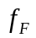, and the flowrate. Your two equations are the mechanical energy balance and a friction factor equation such as the Shacham equation. If you do this in HYSYS you get problems. After specifying the inlet and outlet stream pressures and the pump horsepower the HYSYS solver sits there and doesn’t do anything. The reason for this is that these are sequential solvers. HYSYS needs to solver each operation in a sequence – even though HYSYS can go in the forward or reverse directions.

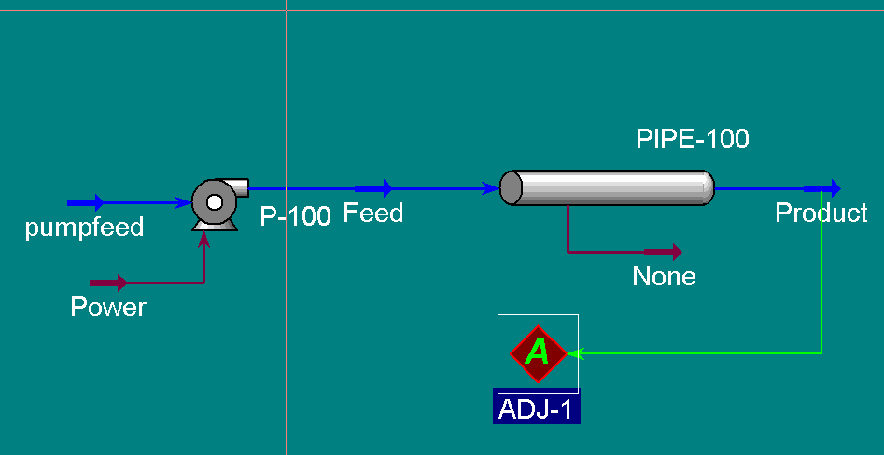
So to solve this problem you have to add a logical operation called an Adjust. (See HYSYS Plant 2.2 menu, Steady State Modeling, Ch 10 Logical Operations.) The adjust takes a variable, (you will need to decide which one) and varies (or adjusts) this variable to obtain the target value of the outlet pressure of 0 psig. The outlet pressure variable is known as the Target variable and the Target value is 0 psig. Remember that you need to delete the outlet variable specification and you need to delete the value of the adjusted variable.

Do the following:
1) Determine the liquid flowrate for problem 5.13 using the adjust logical operation – as shown above.
2) Repeat this analysis for n-butyl alcohol. Use the UNIQUAC activity coefficient model for your thermodynamic property package.
Submit the following:
a) a summary of this work. Compare the results from POLYMATH and HYSYS.
b) your polymath solutions for water and n-butyl alcohol
c) HYSYS printouts of the pfd (graphical) and worksheet (report). Also include the reports from the pump, adjust and pipe unit operations/utilities as done in-class. Since you already have the worksheet printed out then exclude this from your unit operation/utility printouts. See the example below:

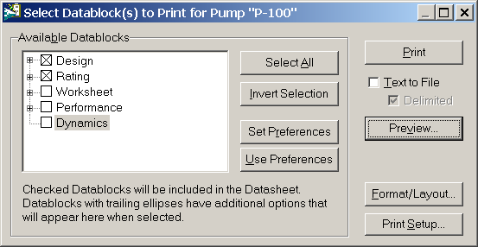

Gregory, G.A., Mandhane, J. and Aziz, K., “Some Design Considerations for Two-Phase Flow in Pipes,” J. Can. Petrol. Technol., Jan. - Mar. (1975).
Beggs, H.D., and Brill, J.P., “A Study of Two-Phase Flow in Inclined Pipes,” J. Petrol. Technol., p. 607, May (1973).
Hyprotech Manuals (in pdf format) HYSYS Plant 2.2, Simulation Basis, Thermodynamics Packages, Appendix A- Property Methods and Calculations, AEA Technology - Hyprotech Ltd., Page A-40.
Keenan, J. H. and Keyes, F. G., Thermodynamic Properties of Steam, Wiley and Sons (1959).
"Thermodynamic and Transport Properties of Steam" - The American Society of Mechanical Engineers - Prepared by C.A. Meyer, R.B. McClintock, G.J. Silvestri and R.C. Spencer Jr.20.

