Physics of Tennis

Background

In tennis, the sweet spot is the area of the racquet which yields the most return and produces the best feel. “The sweet spot is the location on the racquet where the ball seems to fly off the strings with a little effort” [1]. Every racquet has three different sweet spots and these are the center of percussion, node of first harmonic, and the coefficient of restitution or best bounce. The concepts of energy can be used to explain the idea of sweet spots. By using kinetic and potential energy in conjunction with fun sports activities, students are introduced to the physics of tennis.

Objective

The objective of this project is to use the concepts of energy to introduce students to physics by using fun sports activities such as bouncing a tennis ball on a tennis racquet and analyzing the return of the ball.

Materials

- Tennis racquet
- Yard stick
- Tennis balls
- Video Camera (optional)
- Clamp

Procedure 1

- Designate roles to team members – 1) person securing racquet, 2) person dropping tennis ball, 3) person taking measurement, 4) person recording measurement.
- Mark 5 evenly spaced spots (spot 1, 2, 3, 4, and 5) on the racquet with a marker as shown in figure.
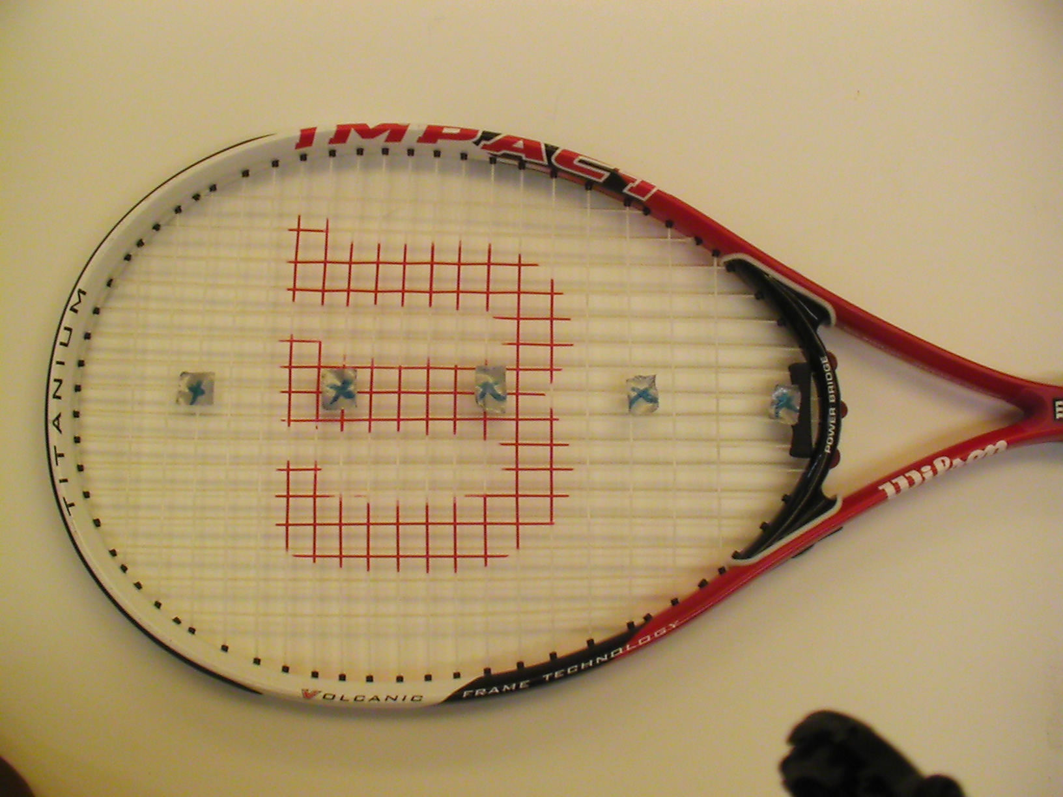
- Place the racquet handle on a table and secure it with a clamp. (similar to holding the racquet by the handle)
- Place the yard stick near the top of the racquet.
- Have the measurement taker and recorder stand near the racquet handle where they can see the racquet and yard stick.
- Have person dropping tennis ball release the tennis ball from the 3 feet high over the first spot on the racquet and record the return measurement.
- Repeat step 6 several times to ensure that the data being recorded are accurate.
- Repeat steps 6 and 7 for each of the 5 spots on the tennis racquet.
Data Table
Ball position | Ball release height | Ball return height | Average return height
1
1
1
2
2
2
3
3
3
4
4
4
5
5
5

Questions

- Did the tennis ball bounce to a height greater, less or the same as its original release point?
- Why do you think this happened? Explain.
- Did the tennis racquet shake (vibrate) when it had an impact with the ball?
- Do you think this in any way could have affected the rebound rate of the ball?
- Which spot(s) on the racquet yields the most return? Spot 1, 2, 3, 4 or 5?

Math Problems

- What is the change in potential energy of a ball when it bounces up from 0 to 0.9144m (3 feet)? Assume the mass of the ball to be 4 kg.
- The velocity of a ball is measured to be 6m/s as it travels from a height of 0m. Determine the height at which the ball will stop. Assume the mass of the ball to be 4 kg.
- If the ball is dropped from the height 1.83m (6 ft) and returned to the height of 1.37m (4.5ft), calculate the percentage of energy lost to other forms of energy (heat, sound, etc) by the tennis racquet strings. Assume there are no vibrations in tennis racquet.
- If 40% of the initial potential energy converted to other forms of energy (heat, sound, etc) find out from what height (m) the ball was dropped to return to the height of 0.9144m (3ft).

[1] Brody Howard, Cross Rod, Lindsey Crawford, “The Physics and Technology of Tennis.” Racquet Tech Publishing, California, 2002

