Physics of Tennis Project

Teacher’s Manual

Background

In tennis, the sweet spot is the area of the racquet which yields the most return and produces the best feel. “The sweet spot is the location on the racquet where the ball seems to fly off the strings with a little effort” [1]. Every racquet has three different sweet spots and these are the center of percussion, node of first harmonic, and the coefficient of restitution or best bounce. The concepts of energy can be used to explain the idea of sweet spots. By using kinetic and potential energy in conjunction with fun sports activities, students are introduced to the physics of tennis.

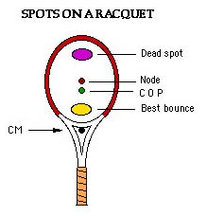
http://www.physics.usyd.edu.au/~cross/tennis_files/image001.jpg

Objective of this Project

The objective of this project is to use the concepts of energy to introduce students to physics by using fun sports activities such as bouncing a tennis ball on a tennis racquet and analyzing the return of the ball.

Safety
It is very important that no one gets hurt during this activity. Please be advised that students might want to play with tennis balls or perhaps the racquets. As fun as this could be, it is absolutely crucial that safety precautions are followed during this activity.

Materials List

Material | Cost
Tennis racquet | $ 10.96
Yardstick | $1.29
Tennis balls | $6.64 ( per 12 balls in pack)
Clamps | NA
Camera (optional) | NA
Total | $18.89
The clamps and camera do not have listed prices because we choose to lower cost by utilizing faculty’s equipment. The teacher can use personal digital Camcorder since it is a very short video and does not require a lot of memory for storage. Also, the clamps were not used in our experiments but it is there just to give the teacher an alternative way for set up.

Procedure for Setup 1

- Clamp the end of the racquet to a table. Ensure that it is stable to minimize vibration. This is could be done by clamping the racquet as close to the throat as possible as shown in the Figure 1below.

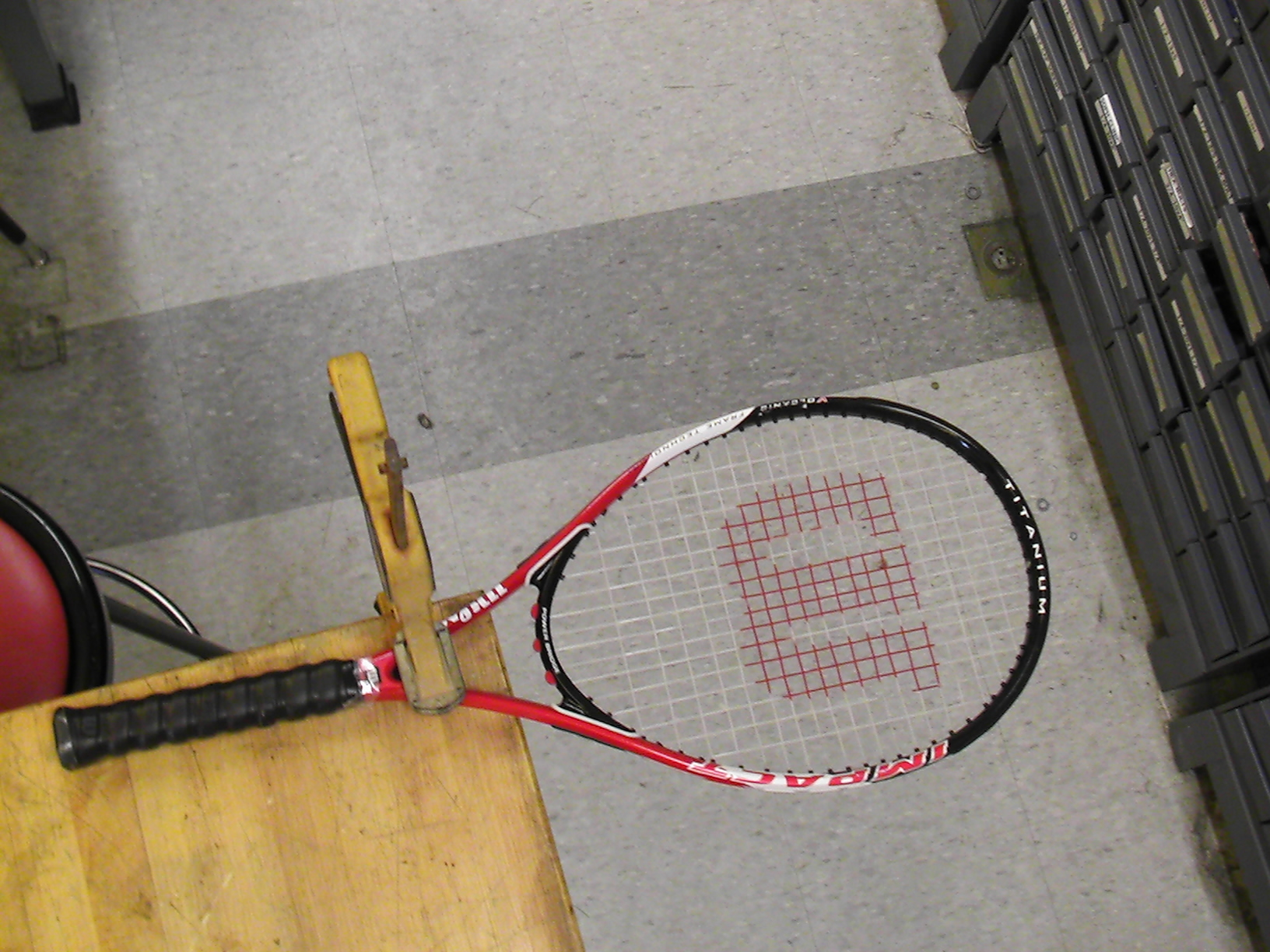
Figure 1: racquet clamped to a table

- Place the yardstick next to the clamped racquet.

Experimental Procedure 1

- Designate roles to team members – 1) person securing racquet, 2) person dropping tennis ball, 3) person taking measurement, 4) person recording measurement.
- Mark 5 evenly spaced spots (spot 1, 2, 3, 4, and 5) on the racquet with a marker as shown in Figure 2.
- Place the racquet handle on a table and secure it with a clamp. (similar to holding the racquet by the handle)
- Place the yard stick near the top of the racquet.
- Have the measurement taker and recorder stand near the racquet handle where they can see the racquet and yard stick.
- Have person dropping tennis ball release the tennis ball from the 3 feet high over the first spot on the racquet and record the return measurement.
- Repeat step 6 several times to ensure that the data being recorded are accurate.
- Repeat steps 6 and 7 for each of the 5 spots on the tennis racquet.

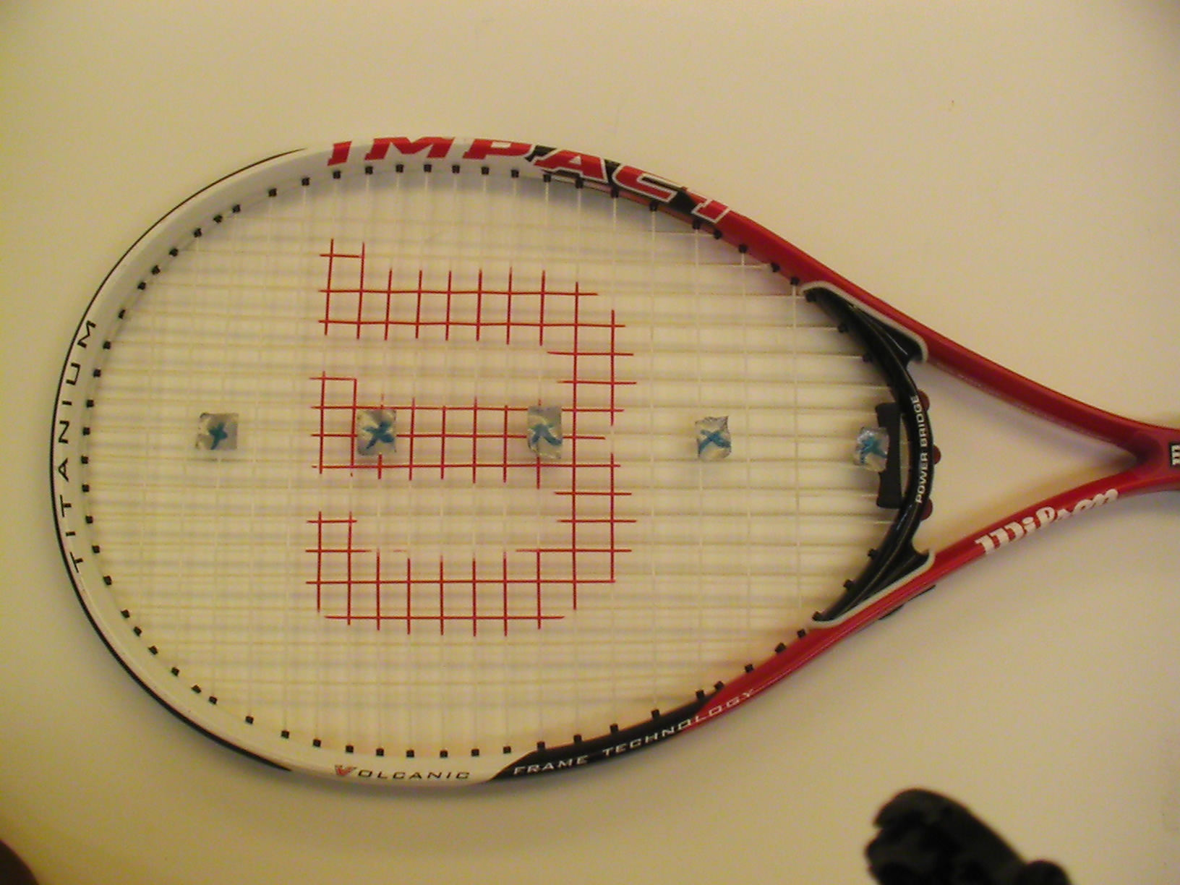
Figure 2: 5 marked spots on a tennis racquet

Optional: You can choose to use a Camcorder instead of using eyesight to be more accurate with your measurements.

Procedure for Setup 2

- The second setup done at Rowan University is quite hard to replicate especially if no drilling machines are available. What the teacher can do is to contact us a week before this activity’s scheduled date and we would be more than glad to build one for them with no cost, as long as we are provided the racquet and yardstick.
If not, then the teacher can follow the following steps to build the stand.

Materials Needed

- Steel blocks
- Screws
- Washers

- You would need 4 steel blocks for each test stand. Preferably ones with the same dimensions to prevent an uneven setup and shaking when the ball impacts with the racquet. This can be easy if one long block is cut into pieces so each would have the same height.

NOTE: It is crucial that you use a heavy metal because something like aluminum will not be able to firmly hold the tennis racquet down. This will cause vibrations and it will affect the results of the experiment.

- Drill a hole in each block according to the screw size you picked.
- Tap holes to enable proper fitting of the screws.

OPTIONAL: If you want the yardstick attached to the racquet as shown in the
Figure 3 below, you would have to drill and tap another hole in only one of the steel blocks. Otherwise, you could attach it to a wall via duct tape or any kind of adhesive tapes available.

- Put all parts together by positioning 2 blocks on the sides of the racquet, and the other 2 at the throat and the tip as shown in Figure 2. Place the washers in between the screw and the hole to ensure a tight fit. The entire assembly is shown in Figure 4.

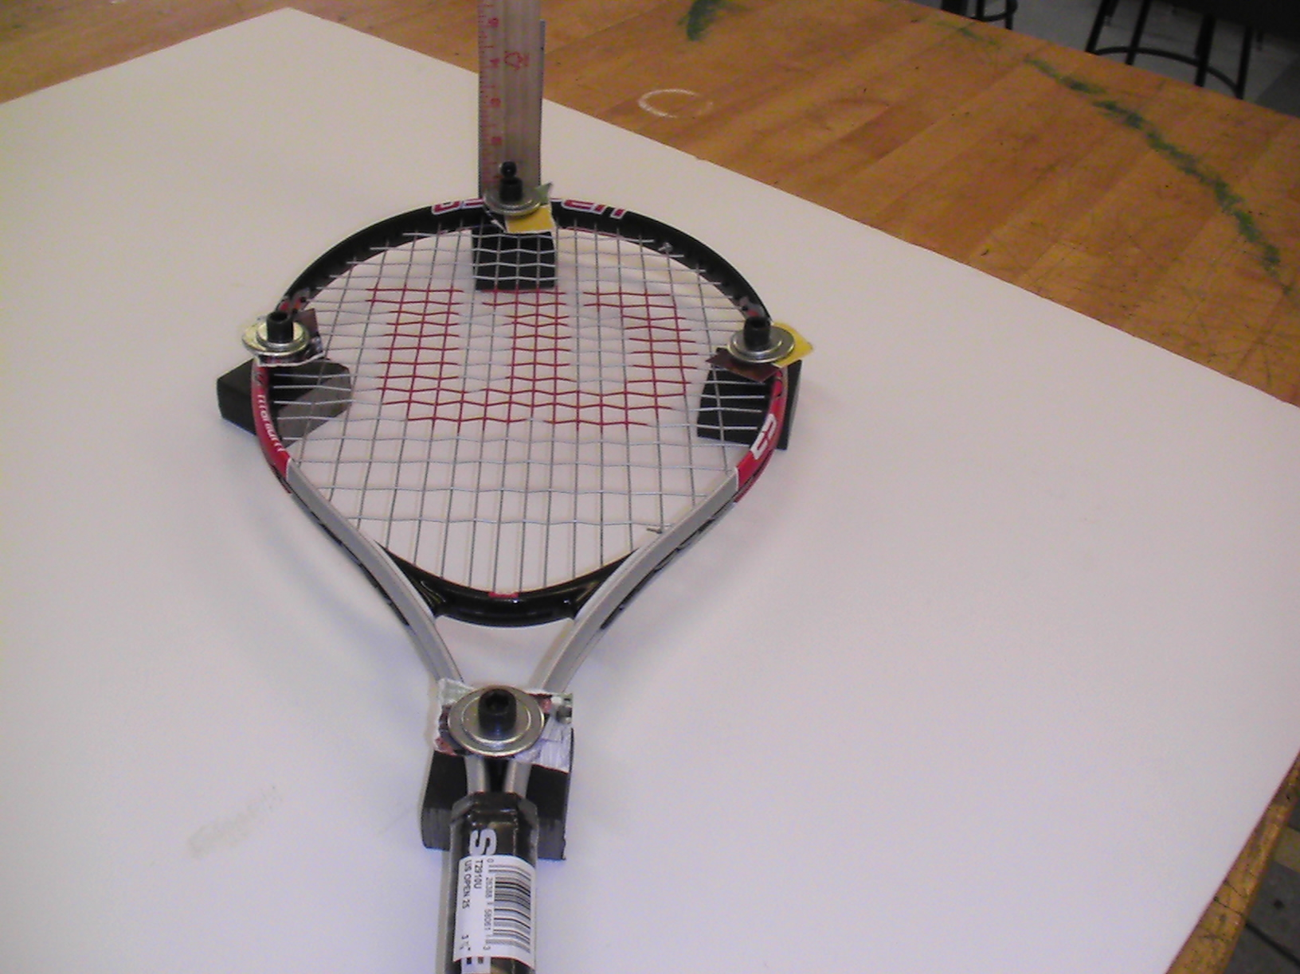
Figure 3: Positioning of the steel block
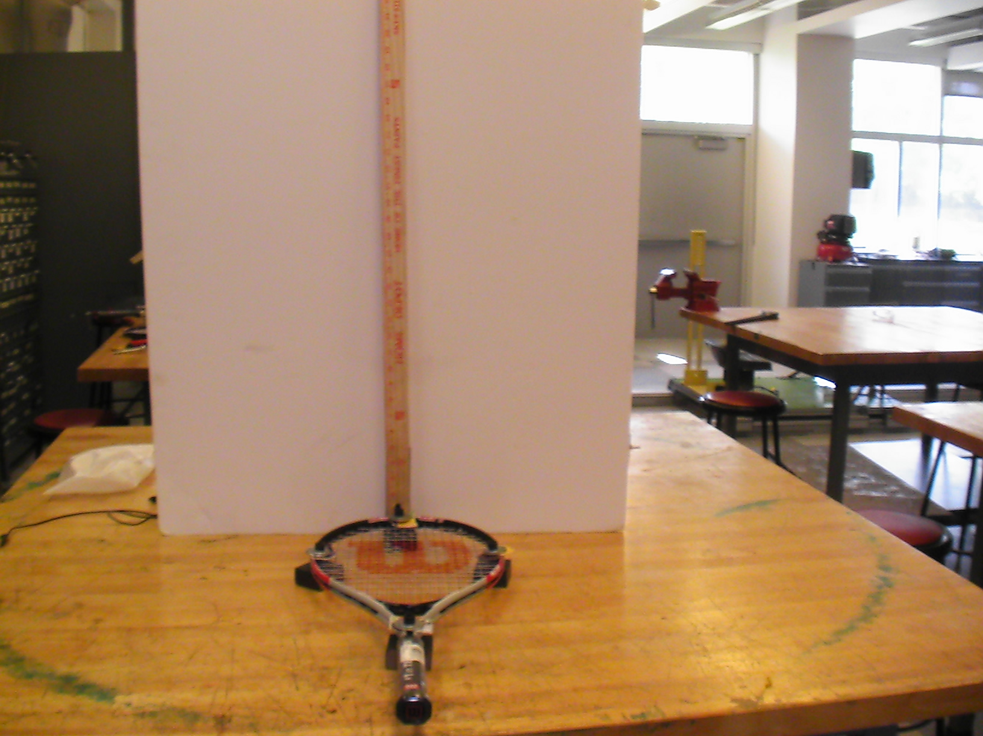
Figure 4: Complete setup

Experimental Procedure

- After setup, the place the camera about 5 feet away and start recording.
- Mark 5 evenly spaced spots on the racquet with a marker. The racquet is about 14 inches long from the tip to the throat so each spot will be 2.8 inches apart.
- Students can now begin experimentation by standing next to the yardstick and releasing the ball from a certain height. It is crucial that this height is recorded (written down) because they will need it later in the analysis. It is also fine if it can be captured in the video.
- This can be repeated as many times as possible. The most important thing is to capture the highest point at which the ball reaches after impact. Usually, the first rebound yields the highest return. The preceding ones can not go past this point due to energy loss.

Note: You can choose to take the measurement by eye if a camera is not available.

Energy

Energy is the conserved property of objects and a system of objects that can neither be created nor destroyed. It is a scalar quantity and it is represented by the symbol E. There are several forms of energy, some are; kinetic energy, potential energy, thermal (heat) energy, electrical energy etc. Only kinetic and potential energy are discussed in this lesson, although other forms of energy can be associated with this project [2].
Kinetic Energy

Kinetic energy is the energy a particle associated with its motion. It is a scalar quantity; it depends only on the particle’s mass and speed, not its direction of motion. A particle gains or loses kinetic energy because it interacts with other particles that exert forces on it. A car has the same kinetic energy when it is going north at 10m/s as when going to east at 10m/s. Kinetic energy can never be negative, and it is zero only when the particle is at rest. The difference in the initial and final kinetic energy is known as the work energy theorem that is, the work done by the net force on a particle equals the change in the particle’s kinetic energy [2].
It is defined by the formula;

K = 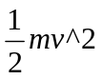
Where m is the particle’s mass and v is the particle’s velocity.

Potential Energy

Potential energy also known as gravitational potential energy is the energy of a particle associated with the position of a system rather than its motion. This means a particle can only have potential energy when it is at rest. The difference in the initial and final potential energy is known is gravitational work [2].
Potential energy is defined by the formula;

U = mgh

Where U is the potential energy, m is the mass of the particle, g is acceleration due to gravity and h is the displacement.

Conservation of Energy

Conservation of Energy states that the energy possessed by particle can neither be created nor destroyed but it can change from one state to another. For example, when the tennis ball impacts with the tennis racquet, the energy possessed by the ball is converted other forms of energy such as heat or sound energy.
The conservation of energy is governed by the formula;

E_{total} = E_{initial} = E_{finial}

E_{initial} = K_{i} + U_{i}

E_{finial} = K_{f} + U_{f} + Energy loss

Where K_{i} is the initial kinetic energy, U_{i} is the initial potential energy, K_{f} is the final kinetic energy, U_{f} is the final potential energy and Energy loss is the other forms of energy such as heat and sound energy.

Questions and Answers

- Did the tennis ball bounce to a height greater, less or the same as its original release point?

Answer: The tennis ball bounced to a height less than its original release point.
Please note: it quite impossible for the ball to bounce past its original release point.

- Why do you think this happened? Explain.

Answer: This is due to energy loss. Although energy can not be destroyed, it can be converted from one state to another. For example, the kinetic energy that the ball possesses when it is in motion can be converted to heat energy when it impacts with the racquet. Therefore, the receding rebounds will never have the same kinetic energy to enable it to reach the same height as the initial release point.

- Did the tennis racquet shake (vibrate) when it impacted with the ball?

Answer: Yes. When the ball impacts the racquet, some of its energy is transferred to the racquet which causes it to vibrate.

- Do you think this in any way could have affected the rebound rate of the ball?

Answer: Yes. Since the racquet is absorbing the ball’s energy at impact, the rebound will be affected due to the energy transfer. This means that the ball will possess less energy after compact.

- Which spots on the racquet yields the most return? Spot 1, 2, 3, 4 or 5?

Answer: The answer will be the spot around the center of the racquet. This is known as the Sweetspot. A Sweetspot is a spot on the racquet that yields the most return without much effort from the from the tennis player.

Math problems

- What is the change in potential energy of a ball when it bounces up from 0 to 0.9144m (3 feet)? Assume the mass of the ball to be 4 kg.
- The velocity of a ball is measured to be 6m/s as it travels from a height of 0m. Determine the height at which the ball will stop. Assume the mass of the ball to be 4 kg.
- If the ball is dropped from the height 1.83m (6 ft) and returned to the height of 1.37m (4.5ft), calculate the percentage of energy lost to other forms of energy (heat, sound, etc) by the tennis racquet strings. Assume there are no vibrations in tennis racquet.
- If 40% of the initial potential energy converted to other forms of energy (heat, sound, etc) find out from what height (m) the ball was dropped to return to the height of 0.9144m (3ft).

Solutions

Math Problem 1
Initial Height
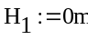
Final Height
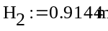
Mass of the Ball
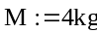
Initial Potential Energy
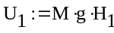
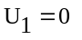
Final Potential Energy
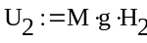
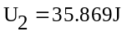
Change in Potential Energy
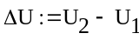

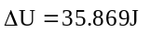

Math Problem 2
Initial Velocity
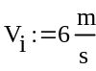
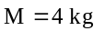
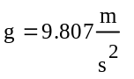
Initial Kinetic Energy
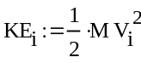
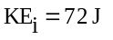
At the final stage all the Kinetic Energy is converted to the Potential Energy. Threrefore
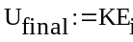
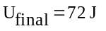
Now U.final = M*g*h2
Final Height
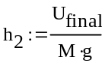
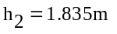

Math Problem 3
Initial Height
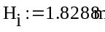
Returned Height
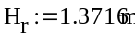
The difference of Height
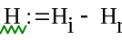
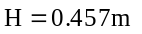
The percentage of energy absorbed by tennis racquet strings
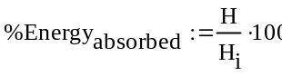

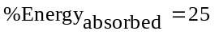

Math Problem 4
Energy absorbed 40%
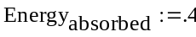
Returned height
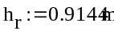
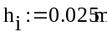
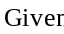
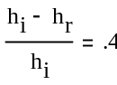
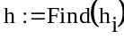
The Initial height
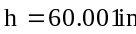
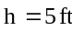
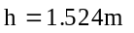

References

[1] Brody Howard, Cross Rod, Lindsey Crawford, “The Physics and Technology of Tennis” Racquet Tech Publishing, California, 2002

[2] Young Hugh, Freedman Roger, “University Physics” eleventh edition, Addison Wesley, San Francisco, 2004.

Other useful resources

Physics of Baseball
http://www.exploratorium.edu/baseball/sweetspot.html
(Science of Baseball: Activity: Finding the Sweetspot)
http://www.physics.usyd.edu.au/~cross/tennis.html
(Tennis Raquet Physics)
http://demo.physics.uiuc.edu/lectdemo/scripts/demo_descript.idc?DemoID=32
(UIUC Physics Lecture Demo: Tennis Racquet and Ball Collision)
http://www.physicscentral.com/lou/2001/racquets.html
(PhysicsCentral: Dear Lou: Tennis Racquet)
http://www.racquetresearch.com/
(Racquet Research)
http://www.exploratorium.edu/baseball/baseketball.html
(Science of Baseball: Activities: Basketball)
http://www.exploratorium.edu/baseball/bouncing_balls.html
(Science of Baseball: Activities: Bouncing Balls)
http://physics-of-sport.net/
(Physics of Sports)
http://www.juliantrubin.com/fairprojects/engineering/sportsengineering.html
(Sports Engineering Science Fair Projects & Experiments)

