Algae Based Problems
- Bangladesh could benefit from manufacturing 5 million tons of biofuel from algae every year. How many tons of methanol would be needed to generate this biofuel?
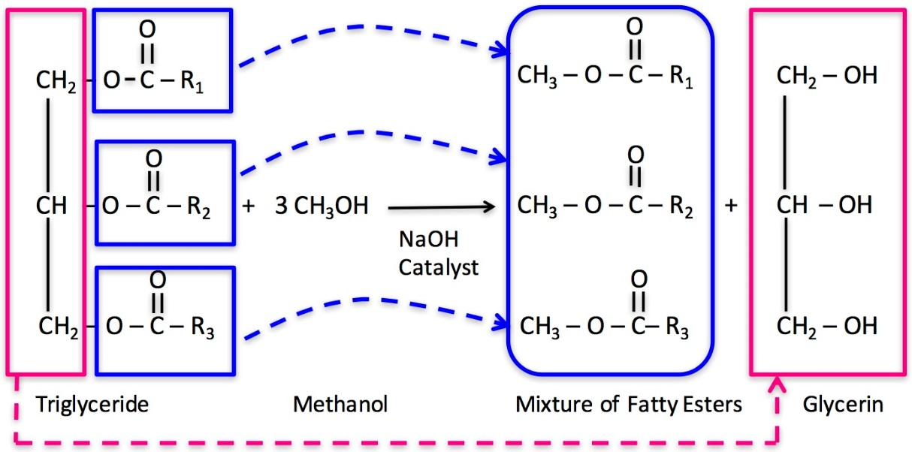

Assume MW : Triglyceride = 300; Glycerin 92; Methanol? ; Biodiesel MW = 309

- How many tons of glycerin will be available for the cosmetics industry?

- How many acres of land will be required for 5 million tons of the biofuel?
Assume 1,850 gallons algae oil/acre-year

Algae density 0.25 kg/m³ 30% of algae is lipid (TAG used to make biodiesel)

- How much water in million gallons will be required to grow the algae needed to produce the 5 million tons of biofuel?

