Lab 5a – Design of an FIR Filter

Objective

- To design a 21-point FIR filter in hardware
- To demonstrate the principle of reuse

Theory

Filtering is one of the most useful signal-processing operations. A common filter used in speech processing is a Finite Impulse Response (FIR) filter. An FIR filter produces an output, y(n), that is the weighted sum of the current and past inputs, x(n). The FIR filter produces these weighted sums by using the convolution equation, which is defined as:
_{N-1}
y(n) = Σ h(k)x(n-k)
^{k = 0}
where h(k) is the impulse response of the given system.

There are several advantages to an FIR filter over an IIR filter. First, FIR filters can be designed to be of linear phase, which means the filter delays the signal but does not distort its phase. Secondly, FIR filters are relatively easy to implement in software and are more precise yet more computationally expensive then IIR filters.

Design

The goal of this lab is to design an FIR filter using the convolution sum in hardware. In block diagram of our design follows:
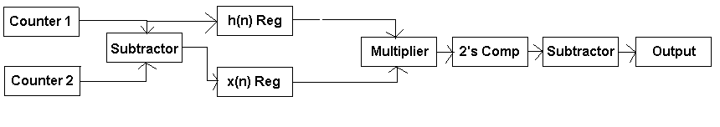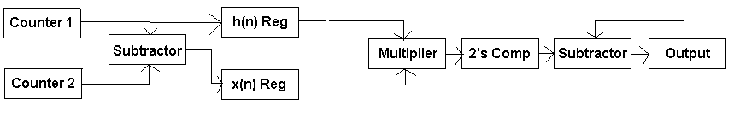
Figure 1 – Block Diagram of an FIR Filter Using the Convolution Sum

The goal of this lab is to design a 21-point FIR filter. The first step that will be to design a 5-bit counter that can reset and increment. Counter 2 will be the master counter and will represent n in the convolution sum. Counter 1 will represent the current k value of the system. When counter 1 equals counter 2, counter 2 will be incremented and counter 1 will be reset. These two counters will be fed into a subtractor. The result of this subtractor will be fed into the 8-bit x(n) register, which will represent (n-k) and call the x value located in that memory address. Counter 1’s value will be fed into the 8-bit h(n) register, which will represent k and call the h value located in that memory location. Both of the values located in these memory locations will be fed into an 8-bit multiplier, which will produce a 16-bit value. Unfortunately, it is easier to multiply two numbers together that are not in two’s compliment so the product must be turned into a two’s compliment value so that it can be added or subtracted. Once the value is fed through the two’s compliment converter, it is fed through a 16-bit subtractor circuit and the difference is stored in a 16-bit output register. If the two counters do not equal each other, then this valued is stored and added to the next value that is produced by the subtractor. If the counters are equal, then the current value is outputted and the register is reset. This process continues until all 21-output values have been computed by the system.

In this lab, several components will be used many times to make larger components and some larger components will be used to make smaller components in an effort to illustrate the concept of reuse.

