Spring 2010 GIS II
Assignment #3

Part I - Raster and Vector Data Models
Raster: Answer the following questions
Imagine an 8 column by 8 row grid over the map below. Create a table that assigns a code number for each land use (nominal data). An empty 8 by 8 table is provided for you. Decide how to best label each grid cell in the blank grid to represent the map. Fill the blank grid with the numbers you assign to the land use categories. Assume that each grid cell represented 200’ x 200’ (approximately an acre), calculate how much area in acres each land use occupies. Add this information to your land use code table.
Issues to consider:
- How will you decide to label mixed grid cells (majority, center point, other)?
- How will you decide to adequately label line features such as the river that has no majority of area and rarely crosses the center point of a cell? (line data)
- How will you decide to adequately label point features such as the house when it has “no” area? (point data)
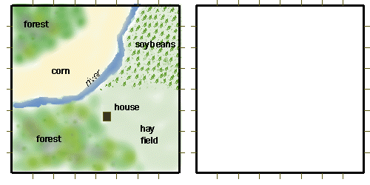

Land use Code Table
CELLID | LU_TYPE | COUNT | ACRES
1 | Forest

- How did you decide to label each of your grid cells (majority, center, other)? Why?
What other criteria could you have used to determine type?
- How spatially accurate did your raster map represent the original map?
- How would the accuracy be affected if there were twice as many rows and columns? Explain.
- How much more memory would be required for twice as many rows and columns?
Vector: Answer the following questions
Complete the tables below. Use the diagram to help you fill in the blanks. When asked for ownership information, Farmer Smith owns the lands north of the river, while Farmer Jones owns south of the river.

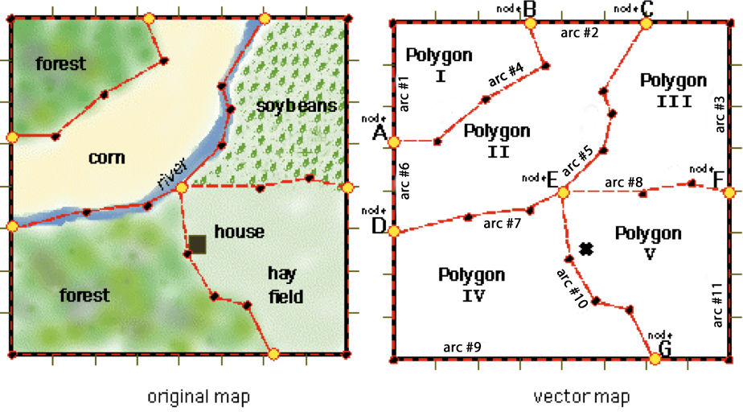

Arc | start node | end node | data point location
#1 | A | B | (0.0,5.2),(0.0,8.0),(3.2,8.0)
#2 | B | C | (3.2,8.0),(6.0,8.0)
#3 | C | F | (6.0,8.0),(8.0,8.0),(8.0,4.0)
#4 | B | A | (3.2,8.0),(3.6,7.0),(2.2,6.2),(1.0,5.2),(0.0,5.2)
#5 | C | E | (6.0,8.0),(5.0,6.4),(5.2,5.8),(5.0,5.0),(4.0,4.0)
#6 | D | A | (0.0,3.0),(0.0,5.2)
#7 | E | D | (4.0,4.0),(3.4,3.5),(1.8,3.4),(0.0,3.0)
#8 | F | E | (8.0,4.0),(7.1,4.2),(5.8,4.0),(4.0,4.0)
#9 | G | D | (6.2,0.0),(0.0,0.0),(0.0,3.0)
#10 | E | G | (6.2,0.0),(5.6,1.2),(4.8,1.4),(4.2,2.4),(4.0,4.0)
#11 | F | G | (8.0,4.4),(8.0,0.0),(6.2,0.0)
Polygon Attribute Table
POLYGON | area (acres) | landuse | owner
I | 6.6ac | forest | Smith
II | 13.9ac
III | 10.3ac
IV | 11.8ac
V | 15.4ac
Arc Attribute Table
Arc | length | arc attibute
#1 | 1241 ft | map edge
#2 | 560 ft | map edge
#3 | 1199 ft
#4 | 1050 ft | forest edge
#5 | 972 ft | river
#6 | 440 ft
#7 | 831 ft
#8 | 807 ft
#9 | 1240 ft
#10 | 988 ft
#11 | 1159 ft

Polygon arc table
POLYGON | Arcs
I
II | #4, #2, #5, #7, #6
III
IV
V
Arc Topology Table
Arc | start node | end node | left polygon | right polygon
#1 | A | B | universe | I
#2
#3
#4
#5 | C | E | III | II
#6
#7
#8
#9
#10
#11
- Which polygons are adjacent to arc #8?
- Which arc does polygon I share with polygon II?
- Which arcs make up the river?
- Which arcs have node E as their end (or beginning) point?
- Which land use polygons are owned by farmer Jones?
- How many acres in total is all of farmer Jones’ property?
- Without spending too much time, think about how you might calculate the area of each polygon. Briefly explain how you might go about calculating the area of Polygon V.
- How would you handle features on the map like the house and the river in this vector dataset?
Part II - Geodatabases and DBMS
- List the data models described in the book on pages 179-192 and summarize each. Include uses, storage requirements, and other important points in your description.
- List a benefit and a drawback in using a geodatabase as opposed to a different data model.
- Explain what a Feature Dataset is and its importance.
- List Ted Codd’s 5 principles for relational databases. (page 222) Why do you think these principles are important?
- List and describe the 9 methods of testing the spatial relationships between features. (pages 226-227)

Using the GIS data provided through the links below*, complete the two following questions. You will need to make a new Personal Geodatabase. Make your selections and export them to the Personal Geodatabase. Do not send shapefiles. Attach the Geodatabase (filename.mdb) as part of your assignment.
(Geodatabase counts for #6, 7, & 8)
- Select all municipalities from nj_muni.shp that are in Gloucester County using Select by Attributes. Save the municipalities as “muni” in your geodatabase.
(Once selected, right click on the layer in the Table of Contents and choose Data>Export Data. Make sure you’re exporting only the selected features. Choose “Yes” when asked to add to the map.)
- Select all points from kcsl.shp that fall within Gloucester County using Select by Location. Save those points to the geodatabase as “kcsl” using the same method as above.
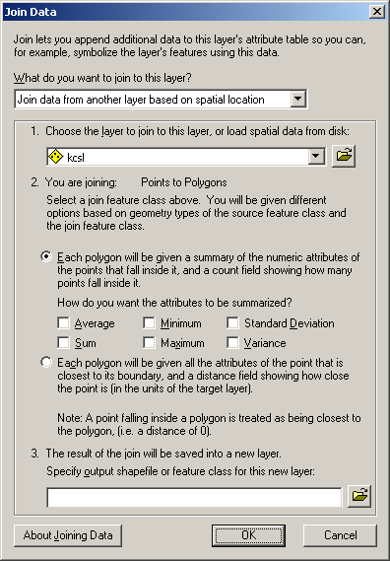
- You will now perform a spatial join on your two datasets. Right click on the “muni” layer you created, and choose “Joins and Relates > Join…” Choose “Join data from another layer based on spatial location.” Choose your “kcsl” you created. It should say “Points to Polygons” as the type of spatial join. You want to get a count of points within polygons, and no additional summary data. Your window should look similar to the one at right.
Perform the join, making sure the new data layer created is created in your geodatabase.
- Using your new layer, give me the count of KCSL points within:
  - Glassboro
  - National Park
  - Deptford
*Known Contaminated Sites (KCSL) is available from the DEP website at http://nj.gov/dep/gis/. The Municipal Boundaries are available from NJGIN: https://njgin.state.nj.us/NJ_NJGINExplorer/DataDownloads.jsp

