Engineering Electromagnetics 1 Midterm Examination

Fall 2002

October 2, 2002
12:30 – 2:30 PM

Student’s Name:

DIRECTIONS: Answer all questions. Report all work for credit. List all assumptions. This exam is OPEN BOOK & NOTES. Print your name on all pages. Remember to specify UNITS for all answers. Use proper NOTATION.

Part I: Warm-up (5 questions; 5 points each)

- If 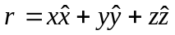is the position vector of the point (x, y, z) and 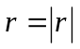, which of the following statements is wrong?

  - 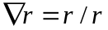

  - 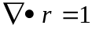

  - 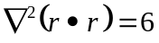

  - 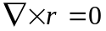

- A wedge in a cylindrical coordinate system is described by z = 0, -π/6 < φ < π/3. Which of the following statements is/are wrong?

  - The wedge lies in the x-y plane.

  - The wedge is infinitely long.

  - On the wedge, 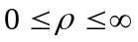

  - A unit normal to the wedge is 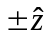

  - The wedge includes neither the x-axis or the y-axis.

- The surface current density in a rectangular waveguide is plotted in Figure 3. Is the following statement TRUE or FALSE – “It is evident from Figure 3 that diverges at the top wall of the waveguide and is divergenceless at the side wall.”
  - TRUE (explain why)
  - FALSE (explain why)
  - Insufficient information (explain what more do you need to know)

Figure 3: Surface current density vector in a rectangular waveguide.

- For each of the scalar electric potential distributions shown in Figure 4, sketch the corresponding 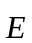 field distribution. In each case, vertical axis is in volts; horizontal axis is in meters.

Figure 4: Scalar electric potential distributions.

- A spherical rubber balloon is charged by friction uniformly over its surface. How does the electric field inside and outside the balloon change if it is periodically inflated and deflated to change its radius? Choose one or more of the following options; or if you have a better answer, write that down.
  - It does not change anywhere.
  - It changes only inside the balloon.
  - When the balloon is inflated, the field at points just outside of it drops to zero; when it is deflated, the fields at points just inside of it jumps from zero to a nonzero value.
  - I am too old to play with balloons….

Part II: Light sprint (10 points)

- For a pair of given sources 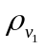 and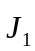, the corresponding electromagnetic fields are 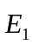, 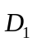, 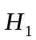, and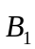. Similarly, for another pair of sources 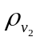 and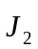, the corresponding electromagnetic fields are 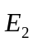, 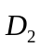, 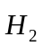, and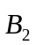. What would the electromagnetic fields be for a pair of sources 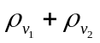and 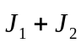? Do these new fields satisfy Maxwell’s equations? What is the name of the theorem that you have just proved?

Part III: Warp-speed (25 points)

- Would it be possible to apply Gauss’ law for the determination of the electric field for a charged plane with non-uniform charge distribution? Choose one of the following answers.
  - Yes (explain how)
  - For some charge distributions (give an example)
  - No (explain why)

- A charge distribution of 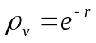μC m⁻³ is set up in air. Find the field distribution everywhere.

