##### ECOMMS Midterm Exam March 26, 2019

#### Spring 2019 5:00 – 7:00 PM

# 

**Student’s Name**:

**DIRECTIONS**: This exam consists of **three** parts – Part A, Part B and Part C. Answer **all** questions in all **three** parts. This exam is **OPEN TEXTBOOK/NOTES, CLOSED COMPUTER/WEB**. Calculators are permitted. Remember to specify UNITS for all answers. Use proper NOTATION. Show ALL WORK.

**Part A** (8 questions @ 5 points each = 40 points)

1. A Samsung 4k Ultra HD TV has 2,160 scan lines and 3,840 pixels per line. If each pixel is quantized with TrueColor 24-bit resolution (8-bits each for Red, Green and Blue respectively), what is the total information contained in each frame? You can assume that each pixel can assume any shade of color with equal probability.
2. Why are Bessel functions used to determine the spectrum of a single-tone modulated FM signal? Write down the time- and frequency- domain expressions of the FM signal and sketch its spectrum.
3. What is the difference between a *baseband* signal and a *bandpass* signal? Why are baseband signals converted to bandpass signals before transmission in wireless communications systems?
4. Describe the *three* fundamental methods by which a sinusoidal carrier can be modulated by a message signal?
5. A single-digit 7-segment LCD display emits 0 with a probability of 0.25; a 1 and 2 with a probability of 0.15 each; 3, 4, 5, 6, 7, and 8 with a probability of 0.07 each; and a 9 with a probability of 0.03. Find the entropy of this digital source.
6. Under what conditions is the *discrete* Fourier transform of a waveform an acceptable approximation of its *continuous* Fourier transform?
7. Speculate on the state of communications technology in the future. In particular, predict the products and services that will be available to an average consumer in:
   1. 2029
   2. 2069
   3. 2119
8. You are given a pure sinusoid, *s*(*t*) = 10 cos(21000*t*) and a zero-mean, unit variance, Gaussian noise signal *n*(*t*) = *N*(0,1). How would you generate a noise signal *n*1(*t*) that can be added to *s*(t) to obtain a noisy signal *s*1(*t*) = *s*(*t*) + *n*1(*t*), such that the SNR of *s*1(*t*) is –3 dB?

**Part B**

1. A commercial broadcast receiver not only has the task of demodulating the incoming RF signal, but must also be able to selectively tune to the carrier frequency and separate the desired signal from other modulated signals that may be picked-up along the way.

The *superheterodyne* receiver performs these functions in an elegant and practical way – specifically, it overcomes the difficulty of having to build a tunable and highly selective and variable filter.

A two-stage coherent detection technique is used. In the first stage, the RF signal is shifted *down* to an *intermediate frequency* (IF) by multiplying it with a local oscillator frequency that is *greater* than the incoming carrier. In the second stage, the signal in the IF range is processed through a second coherent detector to bring it down to the baseband.

Consider a standard-AM signal at a station frequency of 800-kHz, single-tone modulation at 80% depth, that is detected by a superheterodyne receiver with an IF of 455-kHz.

* 1. Draw a block diagram of the 2-stage superheterodyne receiver system described above.
  2. Perform a time- and spectral-domain analysis as the incoming RF signal is converted to IF and then to baseband. In your analysis at each stage of the block diagram, you should provide equations describing the signals in the time- and frequency- domains. Also provide sketches of the signal spectrum at each stage, *clearly indicating all amplitudes and frequencies*.

(20 points)

**Part C**

1. *Ground-based MCAS Malfunction Detection System (MMDS)*

Speculation is mounting that the recent crashes of Lion Air and Ethiopian Airlines flights are due to malfunctions in Boeing 737 Max airplane’s Maneuvering Characteristics Augmentation System (MCAS), which incorrectly identified the angle of attack of the aircraft and forced the nose down, leading to rapid loss of altitude. Both crashes occurred within minutes of takeoff and radar indications of the vertical speeds of each aircraft are shown below.

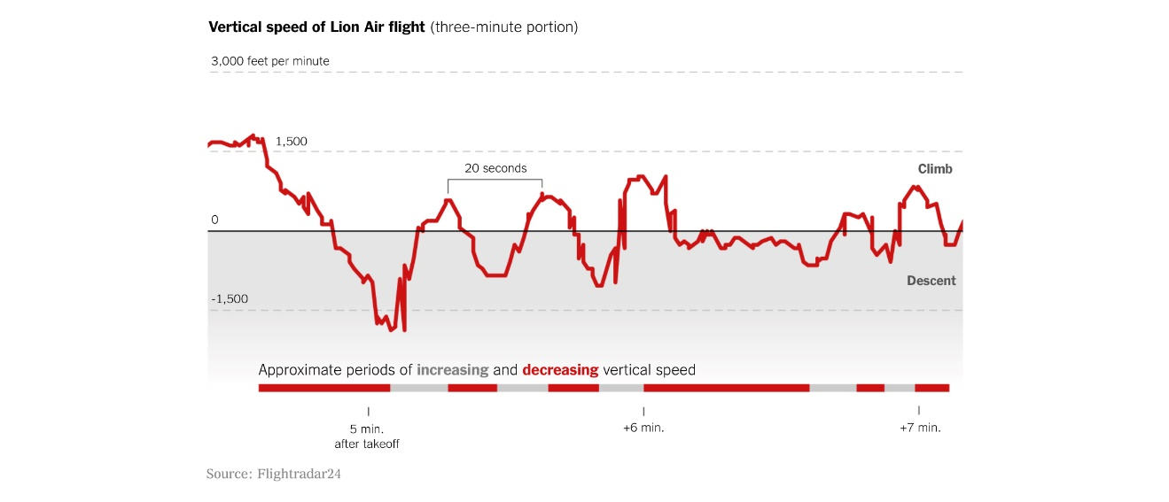

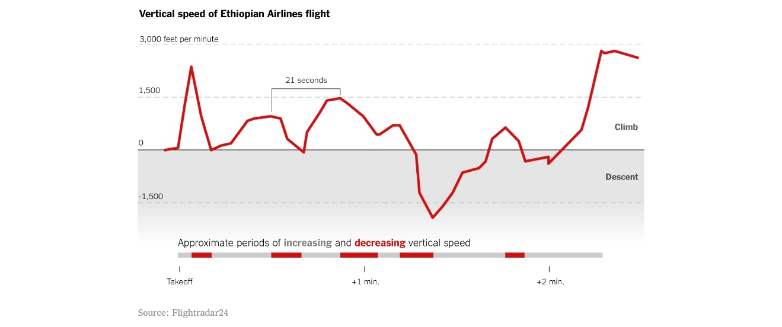

You have been hired by the Philadelphia Airports Authority to design a ground-based MCAS Malfunction Detection System (MMDS). Part of the MMDS is a Doppler-based radar system for detecting the vertical speed of aircraft that are taking off from PHL. This sub-system will be placed alongside the runway and aimed at the departing aircraft, whose vertical speed will then be transmitted to the control tower. The sub-system consists of a sinusoidal generator, which continuously generates the signal,

s(t) = A cos (2fct)

This signal is beamed out to the airplane that is taking off via a horn-antenna. A similar antenna receives the reflected signal, which is of the form

r(t) = B cos [2 fc+f) t]

The situation is shown in Figure 10.

**RX**

**TX**

s(t) = A cos (2fct)

r(t) = B cos [2 fc+f) t]

+

-

Your system here



**Figure 10:** MCAS malfunction detection system for determining vertical speed.

The frequency difference is given by

f = 10 v

where v is the vertical velocity of the airplane in feet-per-min.

Design this MMDS subsystem that displays the departing aircraft vertical speed on a digital display inside the control tower.

(Thank you Tim!)

(40 points)