CEE 311 Environmental Engineering I Fall 2012
Dr. Kauser Jahan, P.E.

Lab # 4: COAGULATION-FLOCCULATION

The Coagulation/Flocculation process is necessary in water treatment primarily because of NONSETTLEABLE SOLIDS, particles too small to be effectively removed by other treatment processes such as sedimentation and filtration. These nonsettleable solids can be changed into larger and heavier settable solids by physical and chemical changes brought about by adding and mixing chemical coagulants in the raw water. These larger and heavier particles can now be removed by sedimentation and filtration processes.

Nonsettleable solids (colloidal suspensions) consist of particles with an electric charge, usually negative. This characteristic prevents the collision and the aggregation of the particles. The addition of certain chemicals to colloidal suspensions can enhance destabilization and aggregation processes, leading to the formation of flocs of considerable dimensions. These flocs can then be further, removed by sedimentation or filtration. A typical flocculation process is shown in Figure 1.

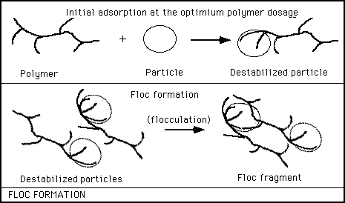

Figure 1: Typical Flocculation Process¹

Coagulants and Flocculants

The common coagulants in water treatment are the trivalent salts of Iron and Aluminum.
Organic polymers, such as polyacrilamides, are usually used as flocculants, in addition to the metallic salts, to improve floc formation.

THE JAR TEST

Jar tests are used in water treatment plants to determine the optimum dose of a coagulant. Results of the test are dependent on current raw water quality, which may vary day-to-day. A typical jar test apparatus is shown in Figure 2. The apparatus is operated to stimulate a mixing, flocculation and settling cycle. Varying amounts of coagulants are added at the same time to the jars that contain water to be treated. The jars are then mixed at high speed for one minute. This rapid mix is followed by a 20-40 minute period of gentle mixing to promote floc growth. The suspension is allowed to settle for a period of 15-60 minutes. The turbidity in each jar is measured and plotted against the coagulant dose. The optimum dose is determined from this plot.

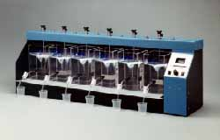

Figure 2: Jar Testing Apparatus²

Engineering Objectives

- To visualize the coagulation-flocculation process in the laboratory
- To determine the optimum dose of Alum [Al2(S04)3 • 18H20] to reduce the turbidity of Rowan Pond Water.
- To use basic chemical reaction stoichiometry in engineering calculations

Laboratory Procedure

- Analyze the raw water for turbidity.
- Place 900 ml of Rowan Pond water into the beakers provided with the apparatus.
- Calculate the alum dosage required for each jar and the volume of alum solution to be added.
- Set paddles at 30 rpm and, using a pipette, measure the appropriate volume of stock alum solution into the beakers. Rapid mix for 1-2 minutes.
- After the 1 - 2 minute coagulation (rapid mixing) step, adjust the mixing speed to about 10 rpm and flocculate for 5 minutes.
- After the flocculation period, remove the paddles and allow solids to settle for 30 minutes.
- Transfer the supernatant (the very top portion of sample) from each jar to a turbidity sample cell, taking care not to disturb the sediment during sampling. Measure and record the turbidity.
- Plot Turbidity versus Alum dose.
- Determine the optimum alum dose.

Report the data obtained from the Jar test in the following tabular form.

Alum Stock Solution Concentration 10,000 mg/L

Jar # | Alum added (mL) | Alum Concentration (mg/L) | Turbidity (NTU)
1
2
3
4
5
6

Plot turbidity versus alum concentration as shown below and determine the optimum alum dose.
Turbidity (NTU)
Alum Dose (mg/L) mg
Optimum Dose

ITEMS NEEDED FOR

LABORATORY REPORT

- Include a Cover Sheet with Team Member Names and Laboratory Name.
- State the Objectives of the Laboratory.
- Include a table showing raw data and calculations.
- Report values of water quality parameters measured in the laboratory. Make sure you have the correct units!!
- Include a Plot of final turbidity (Y-axis) versus coagulant dosage in mg/L(X-axis). Discuss the plot.
- Identify the optimum dose of Alum in mg/L.

These topics should be addressed in the report.

The following reaction takes place when alum is added to the water:

- What chemical composition does the precipitate at the bottom of the jar have?

- What chemical name does this precipitate go by?

- What will happen to the pH and alkalinity of the water as alum is added? Justify your answer.

References:

- http://www.ci.slc.ut.us/utilities/parleys/ February 11, 2002

- http://www.phippsbird.com/products.html#pb-700 February 11, 2002

