In-Class Exercise on Gas Transfer

1. Aeration kinetics can be expressed as follows:
ln(C*-C_{t}) = ln(C*-C_{o}) – K_{L}a t where
C* = saturation concentration of oxygen in water (mass/volume)
C_{t} = oxygen concentration in water at ant time t (mass/volume)
K_{L}a = gas transfer coefficient (time⁻¹)
t= time
Your team has plotted data collected from a gas transfer experiment as shown below and has obtained the equation of the best-fit straight line.

What is the value of K_{L}a in min⁻¹ that can be obtained from this plot? Write appropriate UNITS!

Value of KLa = slope of line = 0.2331 sec⁻¹ = 0.2331 * 60 sec = 13.98 min⁻¹
Sec min

- Two diffusers are to be tested for their oxygen transfer capability. Tests were conducted at 20oC with the following results:

 | Dissolved Oxygen mg/L
Time (minute) | Air Max | Wonder
0 | 2.0 | 3.5
1 | 4.0 | 4.8
2 | 4.8 | 6.0
3 | 5.7 | 6.7

Cs = 9.2 mg/L at 20ºC

Time (minute) | Air Max | Cs-C | ln(Cs-C) | Wonder | Cs-C | ln(Cs-C)
0 | 2 | 7.2 | 1.97408 | 3.5 | 5.7 | 1.740466
1 | 4 | 5.2 | 1.64866 | 4.8 | 4.4 | 1.481605
2 | 4.8 | 4.4 | 1.4816 | 6 | 3.2 | 1.163151
3 | 5.7 | 3.5 | 1.25276 | 6.7 | 2.5 | 0.916291
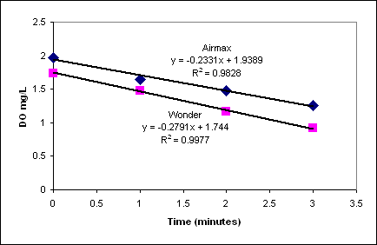

Slope of line is the value of Kla. Wonder Diffuser has a higher KLa.

