Grade Point Averages
Semester | GPA
Fall 2014 | 3.925
Spring 2015 | 3.740
Fall 2015 | 3.738
Spring 2016 | 3.944
Cumulative | 3.838

I have made an extreme effort to improve upon my grades in college. I improved vastly as a student in a college setting. I took the lack of guidance to prove to myself that I am capable of succeeding at a high level. I had a 3.4 GPA in high school and I could not imagine having such low marks in college.

Halfway through my undergrad I am ready to take even more initiative and perform at a higher level. I enjoy being a student and earning an education that not all individuals have the opportunity to receive. I want to take full advantage of my time in school and experience as many things as possible.

Closing Thoughts

How I would explain myself….

Hard Working
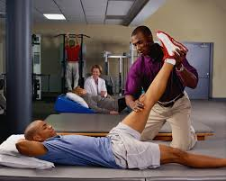
Honest

Compassionate

Calm

Genuine

Contact Me

856-630-6992
ewersk6@students.rowan.edu
111 Forest Road, Moorestown Nj, 08057

Kevin Ewers
Health & Exercise Science

Aspiring Physical Therapist

Student at Rowan University

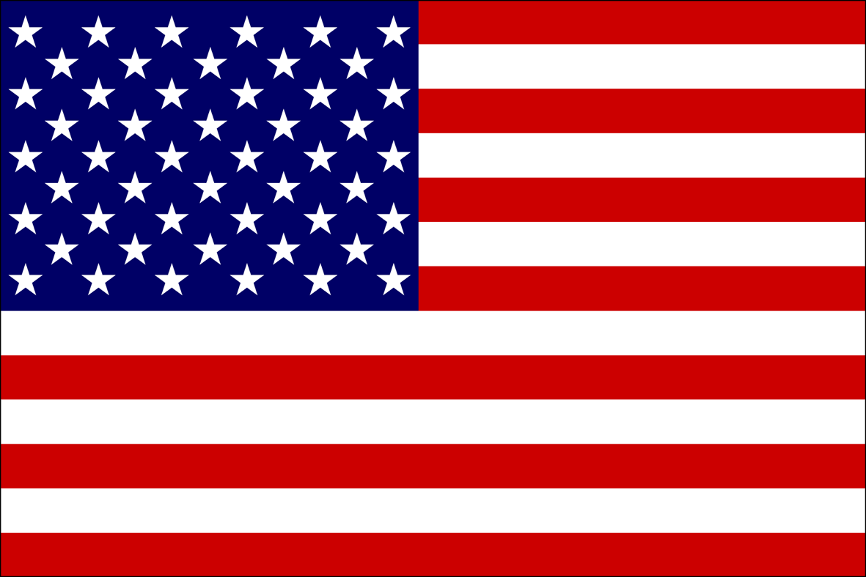

My Involvement at Rowan

Get fit Coach: Working with clients with special needs go through a workout regimen

Rowan Unified Sports:
Volunteering to create a fun environment for those with special needs to compete a moderately high level of physical activity.

President of Phi Kappa Sigma Fraternity
Founding Father of Delta Gamma Colony, Elected President Fall 2016.

Significant Quotes & Beliefs
Do More
-Casey Neistat

Early to bed, early to rise, makes a man healthy, wealthy and wise
- Benjamin Franklin

The importance of consistent hard work and dedication to excel at every aspect of my life is a value that I have no quote for. This is my daily inspiration to myself to keep moving forward
-Kevin Ewers

My Hobbies

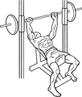

Weight Lifting
Weight lifting has become my most effective stress reliever as well as my favorite hobby.

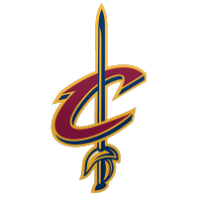
Sports:
I have grown to be an even stronger sports fan than I ever was when I actually played organized sports

Outdoors:
I have spent my entire life doing out activities ranging from camping to fishing
