CEE 311 Introduction to Environmental Engineering Fall 2012
Dr. Kauser Jahan, P.E.

Laboratory 8: Bacteria Enumeration Techniques

Pathogenic organisms present in water and wastewater are difficult to test for, and are often in small numbers. Therefore, the typical approach is to test for the presence of indicator organisms such as the coliform group. The coliform bacteria is present in the intestinal tract of mammals. Although not pathogenic themselves, the presence of coliform bacteria in large numbers may indicate the possibility of contamination of the water supply by fecal matter or insufficient treatment of a wastewater. One analytical method commonly used by regulatory agencies and water utilities to test for coliform is the membrane filter technique. The objective of this laboratory is to conduct this experiment, using different sources of water and wastewater.

Objectives:
- To learn about bacterial growth monitoring and bacteria enumeration techniques.
- Measure Total and Fecal Coliform in tap and surface water.

Methods:
- Quantitative Plating Method
- Membrane Filter Method
- Most Probable Number (MPN)
- Turbidimetry Determinations
- Dry Weight Analyses
- Protein Analyses (Lowry’s Method)

Dry Weight Analyses

This method is the same as measuring total suspended solids and volatile suspended solids. It is assumed that the cell mass concentration is 80% of the total volatile suspended solids.

Therefore by filtering a known volume of sample, the cell dry weight can be estimated as follows:

Cell mass = 0.8 x MLVSS (Mixed Liquor Suspended Solids)

Protein Analyses (Lowry’s Method)

This method assumes that 50% of a cell’s dry weight is protein. Cell Protein can be estimated with Lowry’s method and this protein can be then used to predict cell dry weight.

Turbidity Measurements
Turbidity of a cell suspension increases with increase in cell growth. Thus cell counts and turbidity can be correlated.

Most Probable Number (MPN)
This method is based on the principle of dilution to extinction. It is based on the application of the Poisson distribution.
Quantitative Plating Method

This method is used to culture, identify and enumerate bacteria. The sample to be tested is mixed with agar, allowed to solidify and then incubated. Bacterial colonies are counted after incubation.
Membrane Filter Method
Will be discussed in class

Equipment and Materials:
Filter Apparatus
Petri Dishes
Membrane Filters (0.45 μm) and Pads
Sterilization equipment
mColiBlue Broth

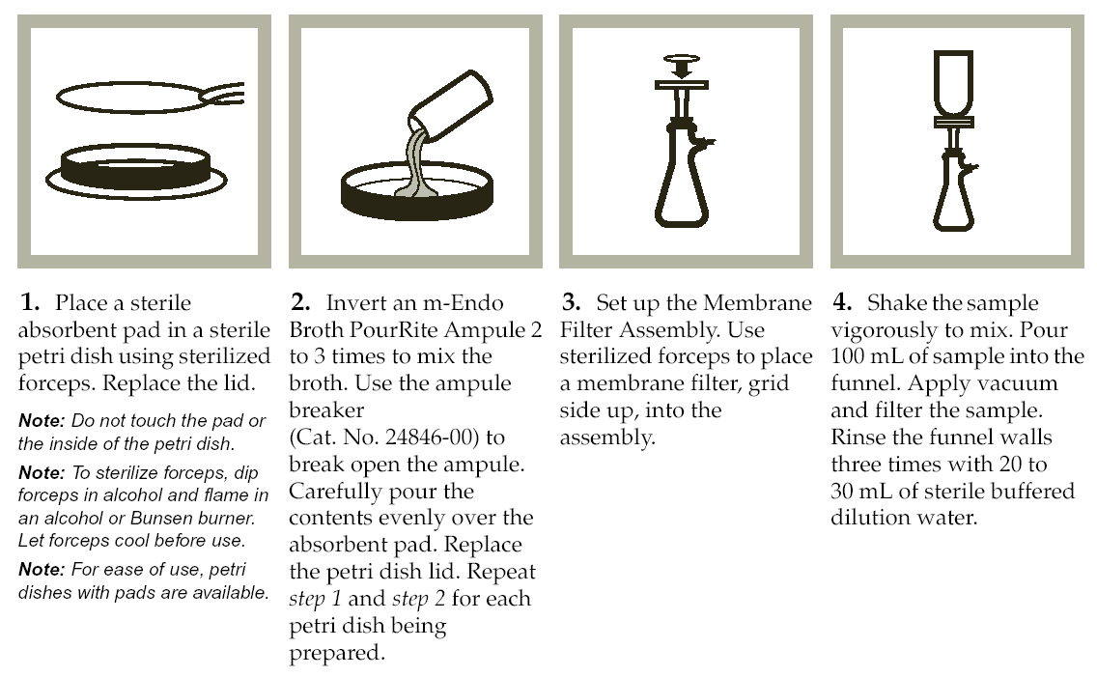
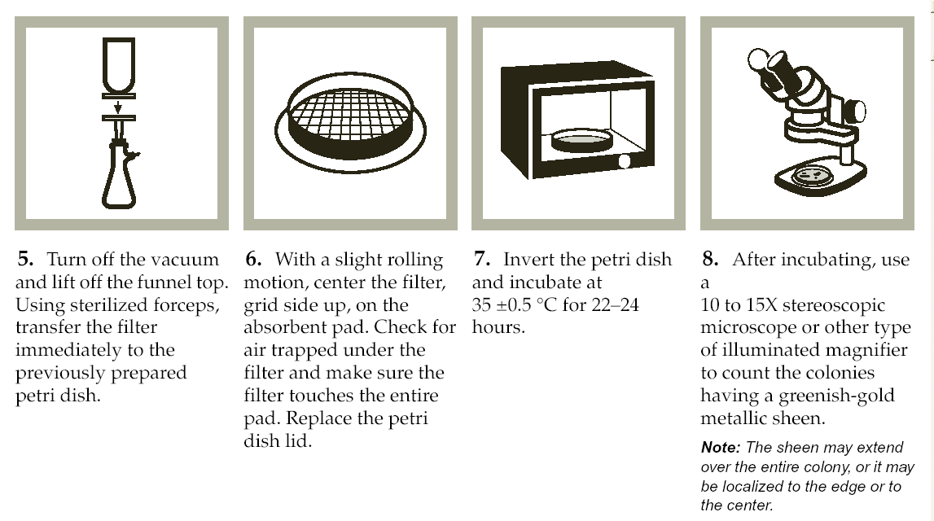

After removal from the incubator count the total number of red and blue colonies. The total is the Total Coliform Count (cfu/100 mL) and the blue colony count is the fecal coliform count.

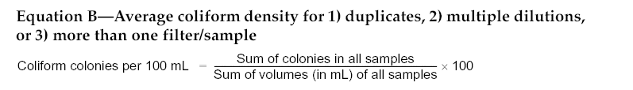

Approximate filtration volume
Source | Approximate Volume
Drinking water | 100
Lakes | 10-100 mL
Bathing beaches | 0.01-10 mL
Streams, rivers | 0.01-10 mL
Unchlorinated wastewater | 0.0001-0.1 mL

The MCLG is the Safe Drinking Water Act is zero coliforms.

Questions:

What is an indicator organism? Name the most common indicator organism.

What properties must an indicator organism have?

Useful References/Sites

http://www.hach.com/Spec/SCOD.htm

APHA, AWWA, WPCF (1995) Standard Methods for the Examination of Water and Wastewater, APHA, Washington, 19th edition.

Benson, H.J., (1998) Microbiological Applications: Laboratory Manual in General Microbiology, McGraw Hill.

Lowry, O. H., Rosebrough, N. J., Farr, A. L. and Randall, R. J. (1951) Protein measurements with the Folin phenol reagent. J. Biol. Chem., 193, 265-275.

Field Manual for Water Quality Monitoring: An Environmental Education Program for Schools, 12th Edition, M.K. Mitchel and W.B. Stapp, Kendall/Hall Publishing Co., 2000.

Troubleshooting Fecal Coliform Cultures
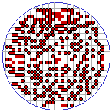 | Sample size too large.
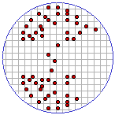 | Uneven distribution is from not swirling the sample while filtering or not adding distilled H₂O to sample.
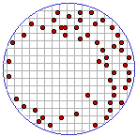 | A dry spot without growth shows improper seating of filter.
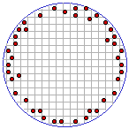 | Growth around sealing edge means unclean filter holder or poor seal.
Adapted from Mitchell and Stapp (2000).

Coliform Data Sheet
Name _________________________
Date _________________________
Site 1 _________________________
Site 2 _________________________
Site 1
Sample | Volume (mL) | Number of Colonies
1 | - | -
2 | - | -
3 | - | -
Site 2--
Sample | Volume (mL) | Number of Colonies
1 | - | -
2 | - | -
3 | - | -
NOTES:

