|  |  |  |  |  |  |  |  |  |  |  |  |  |  |  |  |  |  |  |  |  |  |  |  |
| --- | --- | --- | --- | --- | --- | --- | --- | --- | --- | --- | --- | --- | --- | --- | --- | --- | --- | --- | --- | --- | --- | --- | --- |
| |  |  |  |  |  | | --- | --- | --- | --- | --- | | http://totallyabsurd.com/images/MsSpacer.gif | http://totallyabsurd.com/images/MsSpacer.gif | http://totallyabsurd.com/images/MsSpacer.gif | http://totallyabsurd.com/images/MsSpacer.gif | http://totallyabsurd.com/images/MsSpacer.gif | | http://totallyabsurd.com/MsoPnl_Cnr_tl_11F1.gif | | http://totallyabsurd.com/images/MsSpacer.gif | http://totallyabsurd.com/MsoPnl_Cnr_tr_11F3.gif | | |  | | http://totallyabsurd.com/images/MsSpacer.gif | **Kissing Shield**  Real Patently Absurd Inventions Kissing Shield - Patently Absurd! Actual Patent Illustration - All Inventions Hold Real USA Patents | | | http://totallyabsurd.com/images/MsSpacer.gif | | http://totallyabsurd.com/MsoPnl_Cnr_bl_11F5.gif | |  | http://totallyabsurd.com/MsoPnl_Cnr_br_11F7.gif | | | http://totallyabsurd.com/images/MsSpacer.gif | | http://totallyabsurd.com/MsoPnl_sh_b_11F0.jpg |
| http://totallyabsurd.com/MsoPnl_sh_r_11EF.jpg | |

|  |  |  |  |  |  |  |  |  |  |  |  |  |  |  |  |  |  |
| --- | --- | --- | --- | --- | --- | --- | --- | --- | --- | --- | --- | --- | --- | --- | --- | --- | --- |
| |  |  |  |  |  | | --- | --- | --- | --- | --- | | http://totallyabsurd.com/images/MsSpacer.gif | http://totallyabsurd.com/images/MsSpacer.gif | http://totallyabsurd.com/images/MsSpacer.gif | http://totallyabsurd.com/images/MsSpacer.gif | http://totallyabsurd.com/images/MsSpacer.gif | | http://totallyabsurd.com/MsoPnl_Cnr_tl_220C.gif | | http://totallyabsurd.com/images/MsSpacer.gif | http://totallyabsurd.com/MsoPnl_Cnr_tr_220E.gif | | |  | | http://totallyabsurd.com/images/MsSpacer.gif | |  | | --- | | Kissing Shield  US Patent Issued In 1998  Here it is folks, hot off the presses. If you enjoy kisses but dread the idea of getting a disease, then the Kissing Shield is a "must have" item. This germ barrier consists of a thin latex membrane artfully stretched over an attractive and romantic heart shaped frame.  The inventor states the shield is for kissing the intended recipient of the users affection and is also useful for politicians when kissing babies. Hey, they got our vote. | | | |  | |

|  |  |  |  |  |  |  |  |  |
| --- | --- | --- | --- | --- | --- | --- | --- | --- |
| |  |  |  | | --- | --- | --- | | **Airplane Moisturizer**  From the Patently Absurd Inventions Archive   Airplane Moisturizer - Patently Absurd ! Actual Patent Illustration - All Inventions Hold Real USA Patents | | http://totallyabsurd.com/images/MsSpacer.gif | | http://totallyabsurd.com/MsoPnl_Cnr_bl_133D.gif |  | http://totallyabsurd.com/MsoPnl_Cnr_br_133F.gif | | http://totallyabsurd.com/images/MsSpacer.gif | | http://totallyabsurd.com/MsoPnl_sh_b_1338.jpg |
| http://totallyabsurd.com/MsoPnl_sh_r_1337.jpg | |

|  |  |  |  |  |  |  |  |  |  |  |  |  |  |  |  |  |  |  |
| --- | --- | --- | --- | --- | --- | --- | --- | --- | --- | --- | --- | --- | --- | --- | --- | --- | --- | --- |
| |  |  |  |  |  | | --- | --- | --- | --- | --- | | http://totallyabsurd.com/images/MsSpacer.gif | http://totallyabsurd.com/images/MsSpacer.gif | http://totallyabsurd.com/images/MsSpacer.gif | http://totallyabsurd.com/images/MsSpacer.gif | http://totallyabsurd.com/images/MsSpacer.gif | | http://totallyabsurd.com/MsoPnl_Cnr_tl_234F.gif | | http://totallyabsurd.com/images/MsSpacer.gif | http://totallyabsurd.com/MsoPnl_Cnr_tr_2351.gif | | |  | | http://totallyabsurd.com/images/MsSpacer.gif | |  | | --- | | Airplane Moisturizer US Patent Issued In 1991  Don'tcha just hate long flights on airplanes?  Long lines, cramped seats, bad food and dry air rule the day.  The bad news is that lines are getting longer, the seats aren't getting any bigger and the food… well let's just say that Wolfgang Puck could earn a fortune making flight food edible.  But dry air, for that we have a solution, the Airplane Moisturizer Mask!  As attractive as it is useful, the AMM contains moisture grabbing paper inserts that capture the dampness of your exhales and releases the same moisture back to you as you inhale.  Simple, elegant and especially useful if you are seated next to a chatty Cathy, since your new Hannibal Lecter look will silence more than just the lambs. | | | |  | | |
| |  |  |  | | --- | --- | --- | | **Bag Man**  From the Patently Absurd Inventions Archive   Inventions & Patents - Bag Man - Patently Absurd! Actual Patent Illustration - All Inventions Hold Real USA Patents | | http://totallyabsurd.com/images/MsSpacer.gif | | http://totallyabsurd.com/MsoPnl_Cnr_bl_124D.gif |  | http://totallyabsurd.com/MsoPnl_Cnr_br_124F.gif | | http://totallyabsurd.com/images/MsSpacer.gif | | http://totallyabsurd.com/MsoPnl_sh_b_1248.jpg |
| http://totallyabsurd.com/MsoPnl_sh_r_1247.jpg | |

|  |  |  |  |  |  |  |  |  |  |  |  |  |  |  |  |  |  |
| --- | --- | --- | --- | --- | --- | --- | --- | --- | --- | --- | --- | --- | --- | --- | --- | --- | --- |
| |  |  |  |  |  | | --- | --- | --- | --- | --- | | http://totallyabsurd.com/images/MsSpacer.gif | http://totallyabsurd.com/images/MsSpacer.gif | http://totallyabsurd.com/images/MsSpacer.gif | http://totallyabsurd.com/images/MsSpacer.gif | http://totallyabsurd.com/images/MsSpacer.gif | | http://totallyabsurd.com/MsoPnl_Cnr_tl_2260.gif | | http://totallyabsurd.com/images/MsSpacer.gif | http://totallyabsurd.com/MsoPnl_Cnr_tr_2262.gif | | |  | | http://totallyabsurd.com/images/MsSpacer.gif | |  | | --- | | Bag Man US Patent Issued In 1965  Stadium seats can be hard on ye ole buns and not all stadiums are domed for protection against bad weather.   But you can still enjoy the game while sitting in rain, sleet, hail or snow in the Bag Man, your own personal padded biosphere for fallen fashionistas.   This boxy invention combines a padded seat cushion with a weatherproof zippered cubist contraption that allows you to poke you face out to catch all the action.  It even incorporates a lap flap that not only protects your lap from the elements, it also doubles as a serving tray.   Now all you need to do is to stick your feet in a paper grocery bag to complete your exquisite ensemble. | | | |  | |

|  |  |  |  |  |  |  |  |  |
| --- | --- | --- | --- | --- | --- | --- | --- | --- |
| |  |  |  | | --- | --- | --- | | **Blind Spot Toy** From the Patently Absurd Inventions Archive   Blind Spot Toy - Patently Absurd!   Actual Patent Illustration - All Inventions Hold Real USA Patents | | http://totallyabsurd.com/images/MsSpacer.gif | | http://totallyabsurd.com/MsoPnl_Cnr_bl_1221.gif |  | http://totallyabsurd.com/MsoPnl_Cnr_br_1223.gif | | http://totallyabsurd.com/images/MsSpacer.gif | | http://totallyabsurd.com/MsoPnl_sh_b_121C.jpg |
| http://totallyabsurd.com/MsoPnl_sh_r_121B.jpg | |

|  |  |  |  |  |  |  |  |  |  |  |  |  |  |  |  |  |  |
| --- | --- | --- | --- | --- | --- | --- | --- | --- | --- | --- | --- | --- | --- | --- | --- | --- | --- |
| |  |  |  |  |  | | --- | --- | --- | --- | --- | | http://totallyabsurd.com/images/MsSpacer.gif | http://totallyabsurd.com/images/MsSpacer.gif | http://totallyabsurd.com/images/MsSpacer.gif | http://totallyabsurd.com/images/MsSpacer.gif | http://totallyabsurd.com/images/MsSpacer.gif | | http://totallyabsurd.com/MsoPnl_Cnr_tl_122F.gif | | http://totallyabsurd.com/images/MsSpacer.gif | http://totallyabsurd.com/MsoPnl_Cnr_tr_1231.gif | | |  | | http://totallyabsurd.com/images/MsSpacer.gif | |  | | --- | | Blind Spot Toy  USA Patent Issued In 1994  It is never too early to start your Christmas holiday shopping.  Why not be original this year and avoid the toys that everyone seems to be buying?  Why not give the gift that keeps on giving, the "Apparatus for Aligning Image with Blind Spot of the Eye"!!  Patented in 1975, this toy allows the user to locate their blind spot! In order to play this amazingly fun game, strap the toy tightly on the top of your head.  Close your left eye and focus on the dangling tab with your right eye, then switch eyes.  Voila!  The dangling tab has disappeared into your blind spot.  Not only will this invention provide endless hours of fun and good times for everyone (especially at parties), but anyone wearing this apparatus will unquestionably become irresistible to the opposite sex.  Enjoy! | | | |  | |

|  |  |  |  |  |  |  |  |  |
| --- | --- | --- | --- | --- | --- | --- | --- | --- |
| |  |  |  | | --- | --- | --- | | http://totallyabsurd.com/images/MsSpacer.gif | **Golf Chimes**  Real Patently Absurd Inventions! Golf Chimes - Patently Absurd! Actual Patent Illustration - All Inventions Hold Real USA Patents | http://totallyabsurd.com/images/MsSpacer.gif | | http://totallyabsurd.com/MsoPnl_Cnr_bl_160E.gif |  | http://totallyabsurd.com/MsoPnl_Cnr_br_1610.gif | | http://totallyabsurd.com/images/MsSpacer.gif | | http://totallyabsurd.com/MsoPnl_sh_b_1609.jpg |
| http://totallyabsurd.com/MsoPnl_sh_r_1608.jpg | |

|  |  |  |  |  |  |  |  |  |  |  |  |  |  |  |  |  |  |
| --- | --- | --- | --- | --- | --- | --- | --- | --- | --- | --- | --- | --- | --- | --- | --- | --- | --- |
| |  |  |  |  |  | | --- | --- | --- | --- | --- | | http://totallyabsurd.com/images/MsSpacer.gif | http://totallyabsurd.com/images/MsSpacer.gif | http://totallyabsurd.com/images/MsSpacer.gif | http://totallyabsurd.com/images/MsSpacer.gif | http://totallyabsurd.com/images/MsSpacer.gif | | http://totallyabsurd.com/MsoPnl_Cnr_tl_2F1.gif | | http://totallyabsurd.com/images/MsSpacer.gif | http://totallyabsurd.com/MsoPnl_Cnr_tr_219.gif | | |  | | http://totallyabsurd.com/images/MsSpacer.gif | |  | | --- | | Golf Chimes US Patent Issued In 1996  Ring-a-ding-ding, there's a new way to improve your golf swing, with Golf Chimes!  This musical practice pad features dangling chimes with just enough room for your club to pass through without ringing your bell.  If your swing travels in it's optimum intended path, you will be blessed with silence and the knowledge that you are one with your ball.  Ohmmmm.  But…if you're swing is as bad as ours, you better stake this thing securely into the ground or you may end up chasing your chimes. | | | |  | |

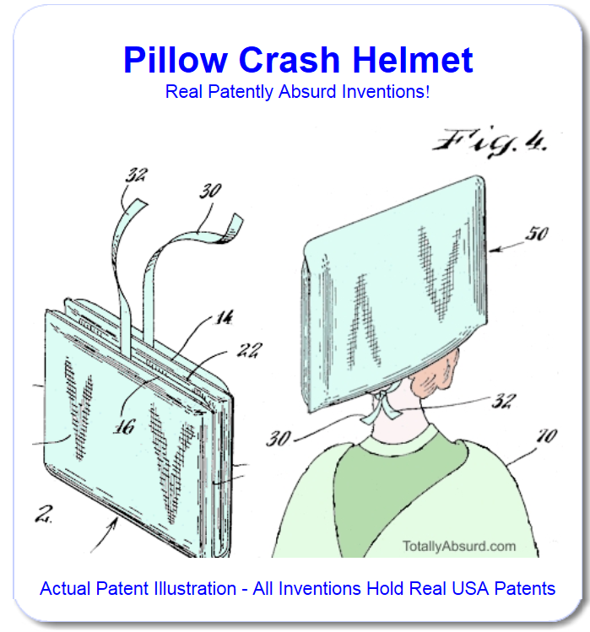

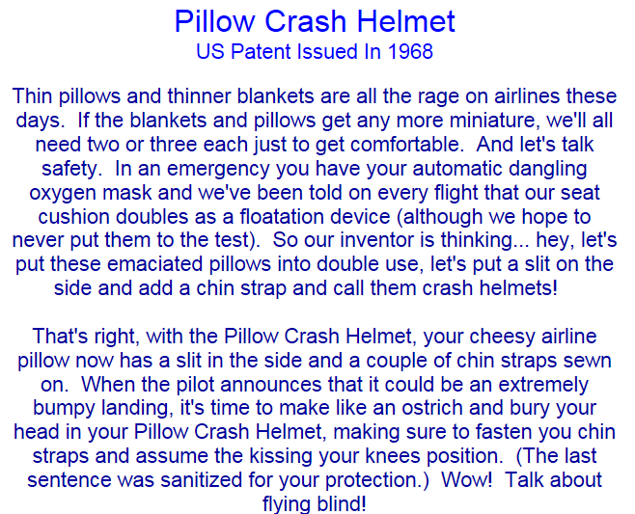

|  |  |  |  |  |  |  |  |  |  |  |  |  |  |  |  |  |  |
| --- | --- | --- | --- | --- | --- | --- | --- | --- | --- | --- | --- | --- | --- | --- | --- | --- | --- |
| |  |  |  |  |  | | --- | --- | --- | --- | --- | | http://totallyabsurd.com/images/MsSpacer.gif | http://totallyabsurd.com/images/MsSpacer.gif | http://totallyabsurd.com/images/MsSpacer.gif | http://totallyabsurd.com/images/MsSpacer.gif | http://totallyabsurd.com/images/MsSpacer.gif | | http://totallyabsurd.com/MsoPnl_Cnr_tl_2B6.gif | | http://totallyabsurd.com/images/MsSpacer.gif | http://totallyabsurd.com/MsoPnl_Cnr_tr_2D6.gif | | |  | | http://totallyabsurd.com/images/MsSpacer.gif | |  | | --- | | Surf Donut US Patent Issued In 1995  To be a real surfer dude requires what?  Well, first and foremost you gotta have some surf!  You know, roiling water with peaks and valleys to push you along as you super glide your way to surfer dude-dom.  But having surf requires having an ocean, and many land-locked dudes would like to be surfers too, dude.  So our inventor dude brainstormed his way to the Surf Donut, a giant spinning drum full of wetness that rotates it's way into creating an artificial surf.  We're not sure exactly how you are going to step into this spherical stream machine and bring your board to a hang ten stance without falling but we are pretty convinced that once you do fall, you are going to flail around inside this thing like a dude caught in a giant washing machine during it's spin cycle! | | | |  | |

|  |  |  |  |  |  |  |  |  |
| --- | --- | --- | --- | --- | --- | --- | --- | --- |
| |  |  |  | | --- | --- | --- | | **Super Trash Man**  Real Patently Absurd Inventions!  Super Trash Man - Patently Absurd ! Actual Patent Illustration - All Inventions Hold Real USA Patents | | http://totallyabsurd.com/images/MsSpacer.gif | | http://totallyabsurd.com/MsoPnl_Cnr_bl_131C.gif |  | http://totallyabsurd.com/MsoPnl_Cnr_br_131E.gif | | http://totallyabsurd.com/images/MsSpacer.gif | | http://totallyabsurd.com/MsoPnl_sh_b_1317.jpg |
| http://totallyabsurd.com/MsoPnl_sh_r_1316.jpg | |

|  |  |  |  |  |  |  |  |  |  |  |  |  |  |  |  |  |  |
| --- | --- | --- | --- | --- | --- | --- | --- | --- | --- | --- | --- | --- | --- | --- | --- | --- | --- |
| |  |  |  |  |  | | --- | --- | --- | --- | --- | | http://totallyabsurd.com/images/MsSpacer.gif | http://totallyabsurd.com/images/MsSpacer.gif | http://totallyabsurd.com/images/MsSpacer.gif | http://totallyabsurd.com/images/MsSpacer.gif | http://totallyabsurd.com/images/MsSpacer.gif | | http://totallyabsurd.com/MsoPnl_Cnr_tl_3B2.gif | | http://totallyabsurd.com/images/MsSpacer.gif | http://totallyabsurd.com/MsoPnl_Cnr_tr_3D2.gif | | |  | | http://totallyabsurd.com/images/MsSpacer.gif | |  | | --- | | Super Trash Man US Patent Issued In 1989  It's a bird! It's a plane! No, it's... it's... it's your neighbor with a trash bag strapped to his back!  That's right folks, collecting garbage with a single stride, annihilating debris with every turn, he is - SUPER TRASH MAN !  Complete with shoulder and feet harnesses, this working class super hero's weapon was invented to help wipe out leaves and grass clippings with a single bound.  Now you too can become a Super Trash Hero; you know, for the kids. | | | |  | |

