Engineering Electromagnetics 1 Midterm Examination

Fall 2004

September 29, 2004
12:40 – 2:40 PM

Student’s Name:

DIRECTIONS: Answer all questions. Report all work for credit. List all assumptions. This exam is OPEN BOOK & NOTES. Print your name on all pages. Remember to specify UNITS for all answers. Use proper NOTATION.

Part I: (5 questions; 5 points each)

- Determine the wavelength at the following signal frequencies:
  - AM radio transmission at 1,060 kHz

  - FM radio transmission at 93.3 MHz

  - Airplane instrument landing system at 335 MHz

  - Satellite communications uplink at 6 GHz.

- Sketch the following fields:

  - $$\vec{F}=z\hat{y}$$
  - $$\vec{P}=ρ\hat{φ}$$

- Write down any two of the Maxwell’s equations and provide a physical interpretation for them.

- How are the electric and magnetic fields as described by Maxwell’s equations related to each other under static conditions?

- Figures 5 (a) and (b) show static electromagnetic field distributions for various situations. Explain briefly whether each situation represents an acceptable electromagnetic field distribution.

Air
High-permeability
Magnetic Material
Magnetic
Field
Lines

Figure 5 (a)
Medium 1
Medium 2
y
x
Medium 1
Medium 2
y
x

Figure 5 (b)

Part II: (10 points)

- A box-shaped surface S₀ enclosing a volume V₀ contains a set of discrete (Q₁, Q₂ and Q₃) and continuous (ρ_{l}, ρ_{s} and ρ_{v}) charge distributions as shown in Figure 2.
l_{O1}, S₀₁ and V₀₁ are, respectively, portions of the line l₁, surface S₁ and volume V₁ contained within S₀. Describe a procedure for computing the electric field over the surface S₀. Provide the relevant equation/s, but DO NOT solve it/them.
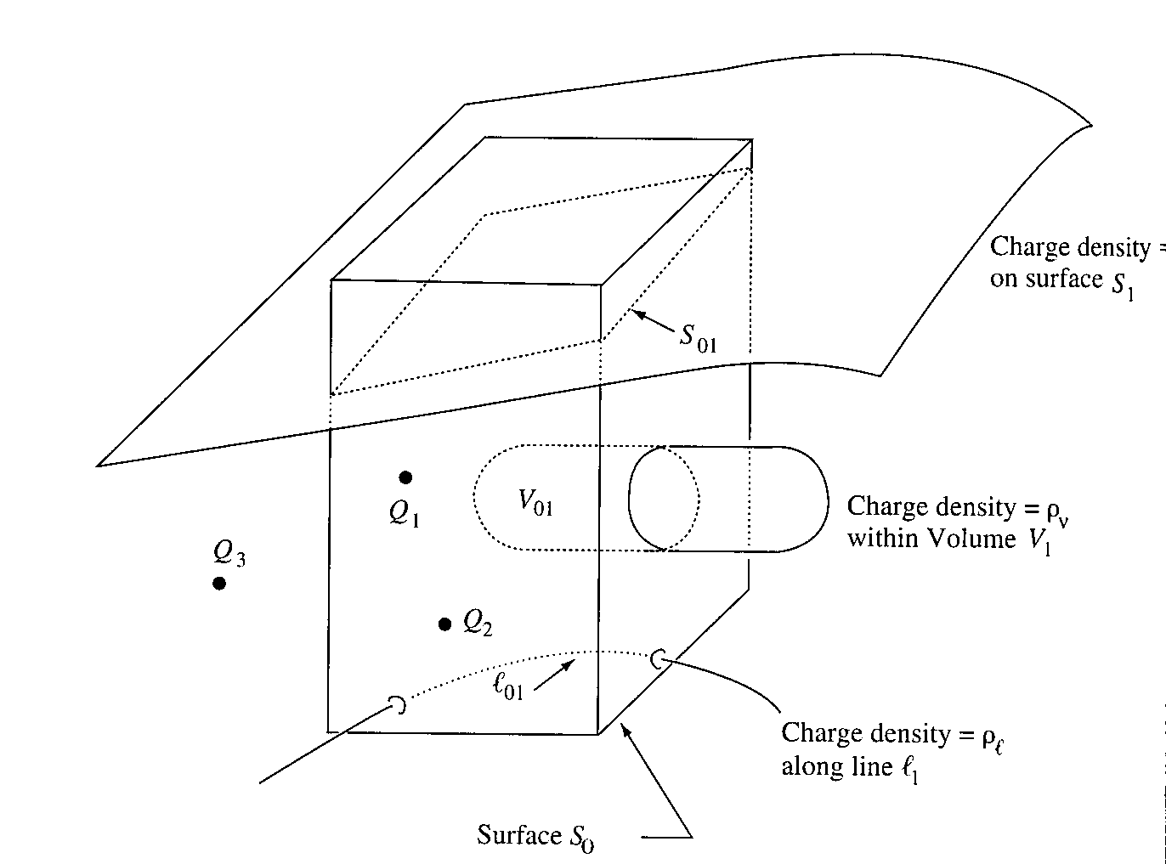

ρ_{s}

Figure 6

Part III: (15 points)

- Find an approximate value for the total charge enclosed in an incremental volume of 10⁻⁹ m³ located at the origin; $\vec{D}=e^{−x}\text{sin}y\hat{x}−e^{−y}\text{cos}y\hat{y}+2z\hat{z}$ Cm⁻².

- Find the amplitude of the displacement current density adjacent to a car antenna receiving an FM radio station where the magnetic field intensity is $\vec{H}=0\text{.}\text{15}\text{cos}\left[3\text{.}\text{12}\left(3×{\text{10}}^{8}t−y\right)\right]\hat{z}$Am⁻¹.

